**FEDERAL INSTITUTE OF SCIENCE AND TECHNOLOGY**

**(FISAT)TM**

**HORMIS NAGAR, MOOKKANNOOR**

**ANGAMALY-683577**



‘**FOCUS ON EXCELLENCE’**

…………………………………………………………………..

**LABORATORY RECORD**

**Name : VAISAKH R MENON**

**Branch : MCA Semester : SECOND**

**Batch : B Roll No : 53**

**FEDERAL INSTITUTE OF SCIENCE AND TECHNOLOGY**

**(FISAT)TM**

**HORMIS NAGAR, MOOKKANNOOR**

**ANGAMALY-683577**



‘**FOCUS ON EXCELLENCE’**

**Name : VAISAKH R MENON**

**Branch : COMPUTER APPLICATION**

**Semester : SEC0ND Roll No: 53**

**University Exam.Reg. No: ..……………………………………..**

**CERTIFICATE**

Certified that this is the Bonafide record of the Practical work done by

Mr/Ms ………………………………………………………in the

………………………………...Laboratory of the Federal Institute of

Science and Technology during the academic year ………………………

Signature of Staff in Charge Signature of H.O.D

Name : Name:

Date :

**Date of University practical examination ………………………**

Signature of Signature of

Internal Examiner External Examiner

***EXPERIMENT -1***

**1. BASIC INTRODUCTORY CONCEPT OF COMPUTER HARDWARE**

1.1 **What is Computer?**

A computer is a programmable electronic device that accepts raw data as input and processes it with a set of instructions (a program) to produce the result as output. It renders output just after performing mathematical and logical operations and can save the output for future use. It can process numerical as well as non-numerical calculations.

**1.2 History of Computers**



Since the evolution of humans, devices have been used for calculations for thousands of years. One of the earliest and well-known devices was an abacus. Then in 1822, the father of computers, **Charles Babbage** began developing the first mechanical computer.

**1.3 Computer Hardware**

Computer hardwareincludes the physical parts of a computer, such as the case, central processing unit (CPU), monitor, mouse, keyboard, computer data storage, graphics card, sound card, speakers and motherboard. Hardware is typically directed by the software to execute any command or [instruction](https://en.wikipedia.org/wiki/Instruction_(computing)). A combination of hardware and software forms a usable [computing](https://en.wikipedia.org/wiki/Computing) system, although [other systems](https://en.wikipedia.org/wiki/Digital_electronics) exist with only hardware.



1.4 The following are the basic components that will be detailed :-

1.4.1 Motherboard

1.4.2. RAM Modules

1.4.3. Daughter cards

1.4.4 Bus slots

1.4.5. SMPS

1.4.6. Internal Storage Devices

1.4.7. Interfacing Ports

**1.4.1 MOTHERBOARD**

A motherboard (also called mainboard, main circuit board, system board, baseboard, planar board ,logic board or mobo) is the main printed circuit board (PCB) in general-purpose computers and other expandable systems. It holds and allows communication between many of the crucial electronic components of a system, such as the central processing unit (CPU) and memory, and provides connectors for other peripherals. Unlike a backplane, a motherboard usually contains significant sub-systems, such as the central processor, the chipset's input/output and memory controllers, interface connectors, and other components integrated for general use.

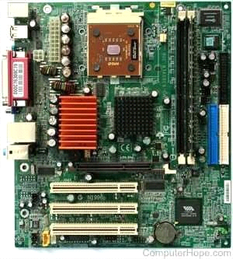

Motherboard means specifically a PCB with expansion capabilities. As the name suggests, this board is often referred to as the "mother" of all components attached to it, which often include peripherals, interface cards, and daughter cards: soundcards, video cards, network cards, host bus adapters, TV tuner cards, IEEE 1394 cards; and a variety of other custom components.

**1.4.1.1 FEATURES OF MOTHERBOARD**

* Motherboard varies greatly in supporting various types of components.
* Motherboard supports a single type of CPU and few types of memories.
* Video cards, hard disks, sound cards have to be compatible with the motherboard to function properly.
* Motherboards, cases, and power supplies must be compatible to work properly together.
  + - 1. **TYPES OF MOTHERBOARD**

**1.4.1.2.1 AT Motherboard**

These motherboards have bigger physical dimensions of hundreds of millimetres and hence they are not the right fit for the mini desktop category of computers.

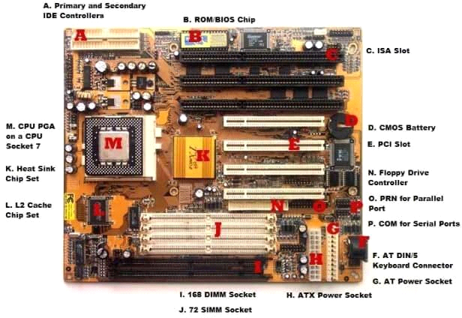

**1.4.1.2.2 ATX Motherboards**

ATX denotes Advanced technology extended, It was developed by Intel during the 1990s and it was an improved version over an earlier version of AT motherboard. It is smaller in size when compared to AT and it provides interchangeability of the connected components.

**1.4.1.2.3 BTX Motherboard**

BTX denotes Balanced Technology Extended, intended to manage demands of new technologies in terms of more power requirements hence generation of more heat.

**1.4.1.2.4 Pico BTX Motherboard**

These boards are smaller in size and hence the word Pico. Two expansion slots are supported in spite of being sharing the top half of BTX. Half-height or riser cards are its unique features and it supports the demands of digital applications.

**1.4.1.2.5 Mini ITX Motherboard**

It’s a miniature version of motherboard. Designed in the early 2000s and its dimension is 17 x 17 cm. Mainly used in small form factor (SFF) computer due to its lower power consumption and faster cooling ability.

* + - 1. **MAIN COMPONENTS OF MOTHERBOARD**

**1.4.1.3.1 FLOPPY DISC CONTROLLER**

A floppy disk controller (FDC) is an electronic chip controller used as an interface between a computer and a floppy disk drive. Modern computers have this chip embedded in the motherboard, whereas they were a separate component when they were originally introduced.

A floppy disk controller (FDC) is a specially designed chip that controls the reading and writing functionality of a floppy drive. An FDC can support up to four floppy disk drives at a time. The controller is connected to the system bus of the CPU and appears as a set of I/O ports to the computer. It is usually also linked to a serial bus of the direct memory access (DMA) controller. In an x86 computer, the floppy disk controller uses IRQ6, whereas interrupt schemes are used on other systems. Data transmission is often done by FDC while in DMA mode.

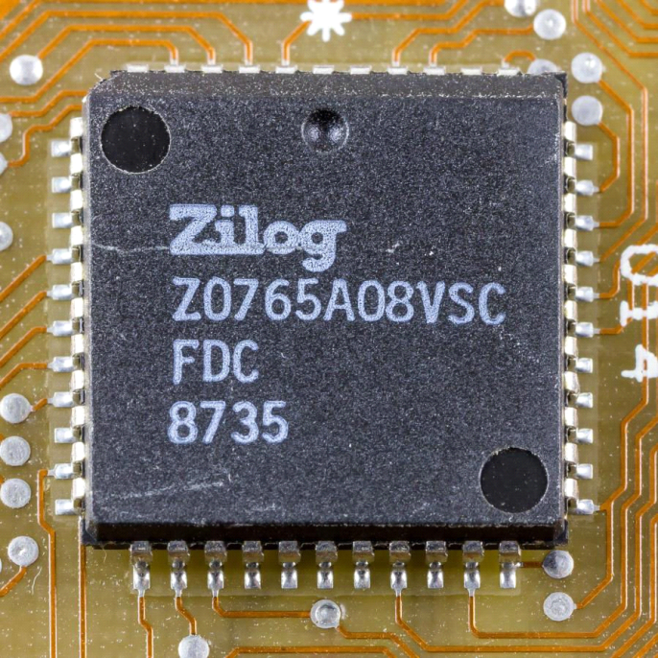

Floppy disk controller functions (FDC)

* Translate data bits into FM, MFM, M²FM, or GCR format to be able to record them
* Interpret and execute commands such as seek, read, write, format, etc.
* Error detection with check sums generation and verification, like CRC
* Synchronize data with phase-locked loop(PLL)

**1.4.1.3.2 Serial Ports**

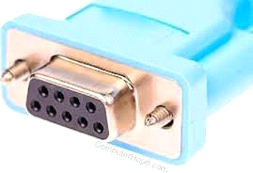

Serial Ports provide an interface to connect serial lines to prepare a serial communication. Serial ports are typically used in modem, mouse, security cameras etc. A Serial port uses DB-9 connector, a 9 pin D-Shaped Connector which connects to the transmission line. A serial port provides a serial communication using one line and thus have no dependency on other wire's speed and its length can be extended as per the need.

**1.4.1.3.3 Parallel Ports**

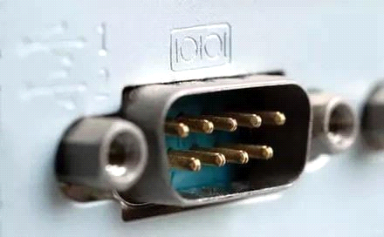

Parallel ports provide an interface to connect multiple lines to prepare a parallel communication to send large data at a time. Parallel ports are used in connecting printers, hard-drives, CD-drives etc. All lines speed should be same to avoid error and cross-talk issues. To avoid such issues, the wires are kept small in length. A parallel port uses D-25 connector, a 25 pin D- Shaped connector which connects to the transmission wires.

**1.4.1.3.4 The Expansion Buses**

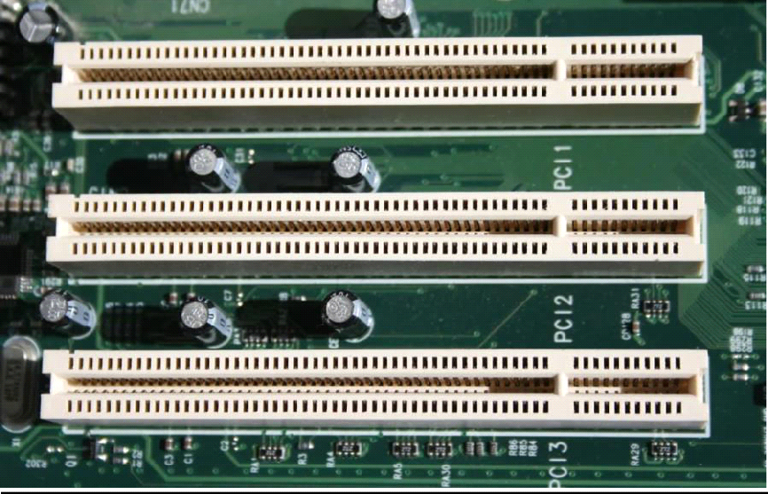

An expansion bus is an input/output pathway from the CPU to peripheral devices and it is typically made up of a series of slots on the motherboard. Expansion boards(cards) plug into the bus. PCI is the most common expansion bus in a PC and other hardware platforms. PCI stands for Peripheral Component Interface; PCI slot allows you to insert expansion cards into your computer. Buses carry signals such as data, memory addresses, power, and control signals from component to component. Other types of buses include ISA and EISA. Expansion buses enhance the PCs capabilities by allowing users to add missing features in their computers by slotting adapter cards into expansion slots.

**1.4.1.3.5 The Computer Chip-sets**

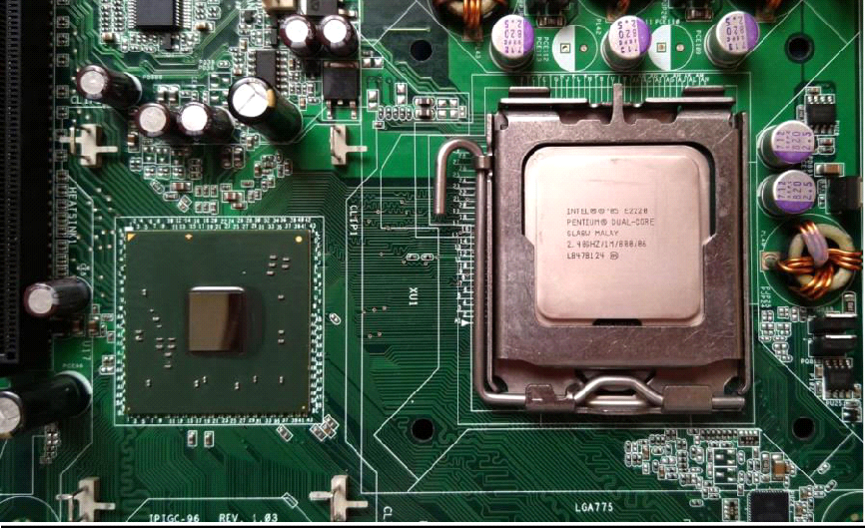

A chipset is a group of small circuits that coordinate the flow of data to and from a PC's key components. These key components include the CPU itself, the main memory, the secondary cache, and any devices situated on the buses. A chip set also controls data flow to and from hard disks and other devices connected to the IDE channels.

A computer has got two main chipsets:

* The North Bridge (also called the memory controller) is in charge of controlling transfers between the processor and the RAM, which is why it is located physically near the processor. It is sometimes called the GMCH, for Graphic and Memory Controller Hub.
* The South Bridge (also called the input/output controller or expansion controller) handles communications between slower peripheral devices. It is also called the ICH (I/O Controller Hub). The term "bridge" is generally used to designate a component which connects two buses.

Chipset manufacturers include SIS, VIA, ALI, and OPTI.

**1.4.2. RANDOM ACCESS MEMORY**

**1.4.2.1. Introduction**

RAM, which stands for Random Access Memory, is a hardware device generally located on the motherboard of a computer and acts as an internal memory of the CPU. It allows CPU store data, program, and program results when you switch on the computer. It is the read and write memory of a computer, which means the information can be written to it as well as read from it.

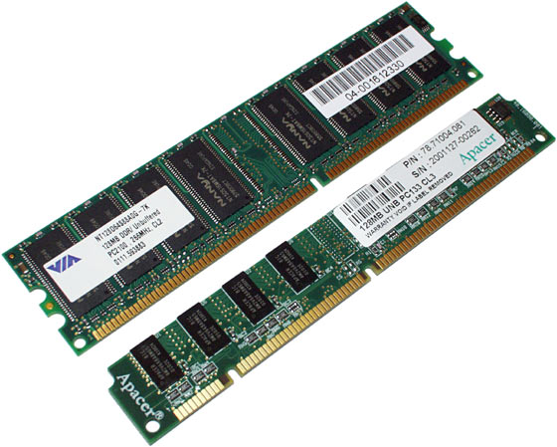

RAM comes in the form of a chip that is individually mounted on the motherboard or in the form of several chips on a small board connected to the motherboard. It is the main memory of a computer. It is faster to write to and read from as compared to other memories such as a hard disk drive (HDD), solid-state drive (SSD), optical drive, etc.

A computer's performance mainly depends on the size or storage capacity of the RAM. If it does not have sufficient RAM (random access memory) to run the OS and software programs, it will result in slower performance. So, the more RAM a computer has, the faster it will work. Information stored in RAM is accessed randomly, not in a sequence as on a CD or hard drive. So, its access time is much faster.

**1.4.2.2. CHARACTERISTICS OF RAM**

**1.4.2.2.1. SDRAM AND DDR**

Memory modules are labelled with either SDRAM (Synchronous Dynamic Random-Access Memory) or DDR (Double Data Rate). DDR RAM, as the "double data rate" name suggests, offers much faster speeds than SDRAM. Each generation of DDR, such as DDR2 and DDR3, offers performance improvements over the one preceding it.

**1.4.2.2.2. SPEED**

The two numbers often quoted first on memory module specifications -- for example, "DDRxxx/PCxxxx" -- indicate the maximum clock speed and maximum transfer rate the device can operate at -- and the higher the better. The stated clock speed is actually double the real figure, so a stick of RAM labelled DDR3-1333 PC3200 offers a clock speed of 666 MHz and a transfer rate of 3,200 MB/s.

**1.4.2.2.3 PINS**

Essentially, the number of pins a memory module has indicates the number of connections it has to the motherboard -- and thus which motherboards it's compatible with. More pins mean more data can be transferred at once, for faster operation overall, though performance is based on a variety of different factors, including CPU speed and the motherboard configuration.

**1.4.2.2.4 VOLTS**

The voltage rating associated with a memory module -- for example, 2.5 V -- indicates how much power it draws from the motherboard in order to operate properly. RAM sticks that can work at lower voltages use up less power and give off less heat, and are therefore more suitable for smaller systems such as laptops.

**1.4.2.2.5 CAS LATENCY**

CAS (Column Address Strobe) Latency, sometimes abbreviated to just "CL," indicates the time it takes for a memory module to return data to the CPU. A lower CAS Latency indicates RAM that performs faster.

**1.4.2.2.6 TIMING**

Memory modules feature other timings besides CAS Latency, usually listed as a series of numbers after the other specifications. In order after CAS Latency, they are RAS (Row Address Strobe) to CAS delay, RAS Precharge, Active to Precharge delay and, optionally, command rate. These timings are only really of interest to advanced technical users, as the impact they have on performance is very small.

**1.4.2.2.7 REDUNDANCY**

The redundancy built into a memory module indicates its ability to recover from errors and to alert the operating system to a problem, rather than just allowing it to crash and lose your data. More expensive and critical server memory uses Error Checking and Correcting Redundancy, or ECC, in order to detect and correct errors wherever possible.

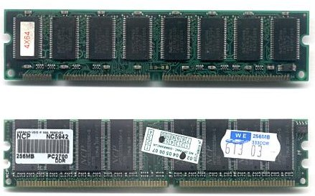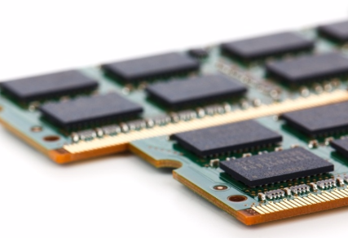

**1.4.2.3. Different Types of RAM**

RAM(Random Access Memory) is a part of computer’s Main Memory which is directly accessible by CPU. RAM is used to Read and Write data into it which is accessed by CPU randomly. RAM is volatile in nature, it means if the power goes off, the stored information is lost. RAM is used to store the data that is currently processed by the CPU. Most of the programs and data that are modifiable are stored in RAM.

Integrated RAM chips are available in two form:

1. SRAM(Static RAM)
2. DRAM(Dynamic RAM)

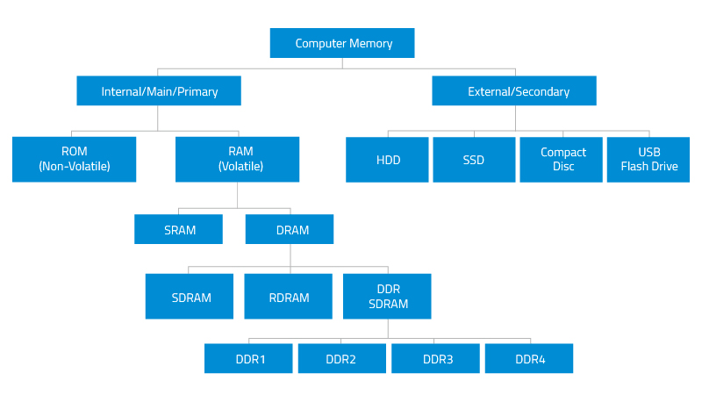

**1.4.2.3.1 SRAM**

The SRAM memories consist of circuits capable of retaining the stored information as long as the power is applied. That means this type of memory requires constant power. SRAM memories are used to build Cache Memory.

**1.4.2.3.2 DRAM**

DRAM stores the binary information in the form of electric charges that applied to capacitors. The stored information on the capacitors tend to lose over a period of time and thus the capacitors must be periodically recharged to retain their usage. The main memory is generally made up of DRAM chips.

**1.4.2.4. Functions**

**1.4.2.4.1. Reading Files**

Hard drives can store vast numbers of files, but compared to other computer components, drives run very slowly. Accessing hard drive files -- especially when those files are scattered across the drive due to fragmentation -- requires the drive to move its mechanical read/write head back and forth and to wait for the spinning platters to spin into the correct position. Even though drives spin at thousands of rotations per minute, this process causes a noticeable delay when reading files. To lessen the slowdown, computers store files in RAM after the files are first read from the drive. RAM has no moving parts, so the files can load very quickly during subsequent uses.

**1.4.2.4.2 Temporary Storage**

In addition to storing files read from the hard drive, RAM also stores data that programs are actively using but that doesn't need to be saved permanently. By keeping this data in RAM, programs can work with it quickly, improving speed and responsiveness.

**1.4.2.4.3 RAM Size**

If RAM works so much faster than the hard drive, why not load all of the computer's data into RAM? One major reason: computers have far less RAM than drive space. As of publication, hard drive sizes range from a few hundred gigabytes in laptops to 10TB in high-end enterprise systems. Most home computers have between 1 and 4TB of drive space.

**1.4.3 DAUGHTER CARD**

Referred to as a piggyback board and **daughter card**, a daughterboard is an expansion board that connects directly to the motherboard and gives added functionality.

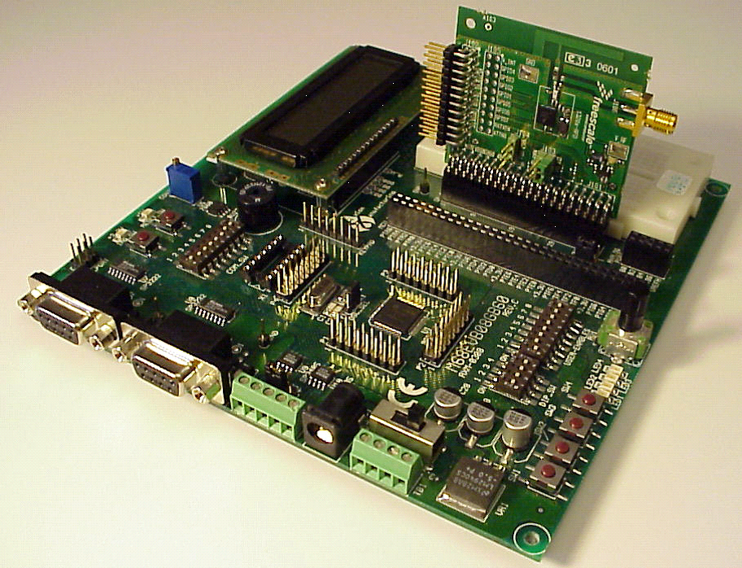

Motherboard with daughter card

To disable a daughter board, the user must physically remove it from the motherboard Daughter boards do not provide new functions to the circuit like an expansion but they extend the circuitry of the circuit in which they are plugged into

**1.4.3.1 Functionalities of daughter board:**

* It is known as the piggyback board, riser card, daughtercard etcetera.
* A daughter board is smaller than a motherboard and may have some slots like the motherboard.
* A daughter board is a printed circuit board which is connected to the motherboard or expansion card.
* Unlike expansion card, daughter boards are directly connected to the motherboard by soldering.
* Daughter boards do not provide new functions to the circuit like an expansion but they extend the circuitry of the circuit in which they are plugged into.
* Daughter boards are released by the vendors as an update of motherboard or expansion card.

**1.4.3.2 List of daughter cards**

* Video Card: This is also referred to as the graphics adapter, display adapter or video adapter.
* Sound Card: To handle sound, to insert a microphone or connect a speaker this sound card is used.
* Network Interface Card: This is also referred as NIC. The computer can be connected to a network only with the use of this network interface card.
* Ethernet Card: Ethernet card is used to connect computers to computers. A cable is used to connect the Ethernet cards in each computer to make a network.

**1.4.4. SWITCHED- MODE POWER SUPPLY**

Switched-mode power supply Introduction A switched-mode power supply (switching-mode power supply, switch-mode power supply, switched power supply, SMPS, or switcher) is an electronic power supply that incorporates a switching regulator to convert electrical power efficiently. Its function is to convert a level of voltage to the voltage or current required by the client through different forms of architecture.

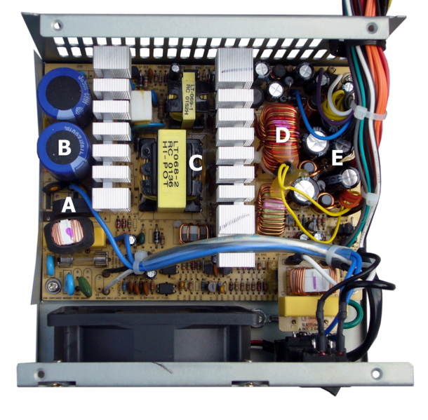

**WORKING**

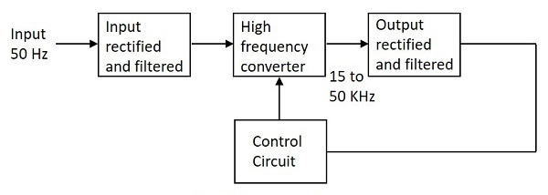

The working of SMPS is simply understood by knowing that the transistor used in LPS is used to control the voltage drop while the transistor in SMPS is used as a controlled switch. The AC input supply signal 50 Hz is given directly to the rectifier and filter circuit combination without using any transformer. A fast switching device such as a Power transistor is employed in this section, which switches ON and OFF according to the variations and this output is given to the primary of the transformer. This is a regulated output voltage which is then given to the control circuit, which is a feedback circuit

**1.4.5. INTERNAL STORAGE DEVICES**

A storage device is any type of computing hardware that is used for storing, porting or extracting data files and objects. Storage devices can hold and store information both temporarily and permanently. They may be internal or external to a computer.

Some storage devices are classed as 'internal' which means they are inside the computer case. At the most basic level, internal storage is needed to hold the operating system so that the computer is able to access the input and output devices. It will also be used to store the applications software that you use and more than likely, the original copies of your data files.

Internal storage allows the data and applications to be loaded very rapidly into memory, ready for use. The data can be accessed much faster than data which is stored on an external storage device. This is because internal storage devices are connected directly to the motherboard and its data bus whereas external devices are connected through a hardware interface such as USB, which means they are considerably slower to access.

The main disadvantage of internal storage is that when the hard disk fails (and it will), all the data and applications may be lost. This can be avoided to some extent by using more than one hard disk within the machine. Each hard disk has a copy of all the data, so if one fails the other can carry on. This is called a RAID array. An alternative is to use external drives for backup

**1.4.5.1. Examples of Internal storage devices**

* Hard Disk
* SSD
* RAM

**1.4.5.1.1. HARD DISK**

A **hard disk drive** (sometimes abbreviated as a **hard drive**, **HD**, or **HDD**) is a [non-volatile](https://www.computerhope.com/jargon/n/nonvolat.htm) data [storage device](https://www.computerhope.com/jargon/s/stordevi.htm). It is usually installed internally in a computer, attached directly to the disk controller of the computer's [motherboard](https://www.computerhope.com/jargon/m/mothboar.htm). It contains one or more [platters](https://www.computerhope.com/jargon/p/platter.htm), housed inside of an air-sealed casing. Data is written to the platters using a magnetic head, which moves rapidly over them as they spin.

[Internal](https://www.computerhope.com/jargon/i/internal.htm) hard disks reside in a [drive bay](https://www.computerhope.com/jargon/b/bay.htm), connected to the motherboard using an [ATA](https://www.computerhope.com/jargon/a/ata.htm), [SCSI](https://www.computerhope.com/jargon/s/scsi.htm), or [SATA](https://www.computerhope.com/jargon/s/sata.htm) cable. They are powered by a connection to the computer's [PSU](https://www.computerhope.com/jargon/p/power-supply.htm) (power supply unit).

Hard disk, Magnetic storage medium for a [microcomputer](https://www.britannica.com/technology/microcomputer). Hard disks are flat, circular plates made of aluminum or glass and coated with a magnetic material. Hard disks for [personal computers](https://www.britannica.com/technology/personal-computer) can store up to several gigabytes (billions of bytes) of information. Data are stored on their surfaces in concentric tracks. A small electromagnet, called a magnetic head, writes a [binary digit](https://www.britannica.com/technology/bit-communications) (1 or 0) by magnetizing tiny spots on the spinning disk in different directions and reads digits by detecting the magnetization direction of the spots. A computer’s hard drive is a device consisting of several hard disks, read/write heads, a drive motor to spin the disks, and a small amount of circuitry, all sealed in a metal case to protect the disks from dust. In addition to referring to the disks themselves, the term hard disk is also used to refer to the whole hard drive.

Computers rely on hard disk drives (HDDs) to store data permanently. They are storage devices used to save and retrieve digital information that will be required for future reference.

Hard drives are non-volatile, meaning that they retain data even when they do not have power. The information stored remains safe and intact unless the hard drive is destroyed or interfered with. The information is stored or retrieved in a random-access manner as opposed to sequential access. This implies that blocks of data can be accessed at any time they are required without going through other data blocks.

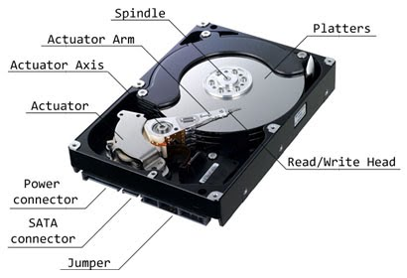

**1.4.5.1.2. SOLID STATE DRIVE**

A solid-state drive (SSD) is a [solid-state storage](https://en.wikipedia.org/wiki/Solid-state_storage) device that uses [integrated circuit](https://en.wikipedia.org/wiki/Integrated_circuit) assemblies to store data [persistently](https://en.wikipedia.org/wiki/Persistence_(computer_science)) , typically using [flash memory](https://en.wikipedia.org/wiki/Flash_memory), and functioning as [secondary storage](https://en.wikipedia.org/wiki/Secondary_storage) in the [hierarchy of computer storage](https://en.wikipedia.org/wiki/Computer_data_storage#Hierarchy_of_storage). It is also sometimes called a **solid-state** **device** or a **solid-state disk**,  even though SSDs lack the physical spinning [disks](https://en.wikipedia.org/wiki/Hard_disk_drive_platter) and movable [read–write heads](https://en.wikipedia.org/wiki/Disk_read-and-write_head) used in [hard disk drives](https://en.wikipedia.org/wiki/Hard_disk_drive) (HDDs) and [floppy disks](https://en.wikipedia.org/wiki/Floppy_disk).

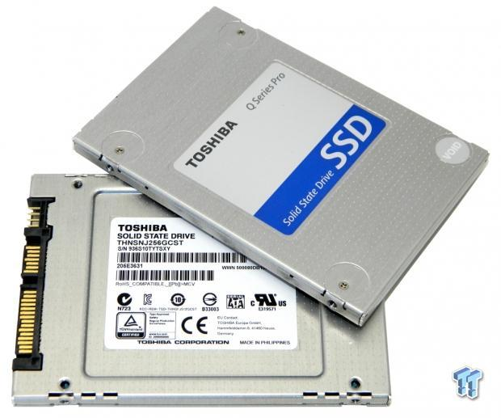Compared with electromechanical drives, SSDs are typically more resistant to physical shock, run silently, and have quicker [access time](https://en.wikipedia.org/wiki/Access_time) and lower [latency](https://en.wikipedia.org/wiki/Latency_(engineering)). SSDs store data in [semiconductor](https://en.wikipedia.org/wiki/Semiconductor) cells. SSDs have a limited number of writes, and slow as they reach storage capacity.

**1.4.5.1.3. RAM**

RAM (Random Access Memory) is the internal memory of the CPU for storing data, program, and program result. It is a read/write memory which stores data until the machine is working. As soon as the machine is switched off, data is erased.

RAM is volatile, i.e. data stored in it is lost when we switch off the computer or if there is a power failure. RAM is small, both in terms of its physical size and in the amount of data it can hold.

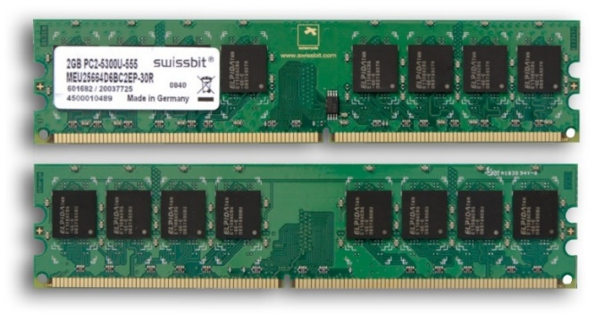

RAM is of two types −

* Static RAM (SRAM)
* Dynamic RAM (DRAM)

**1.4.5.2. Static RAM (SRAM)**

The word **static** indicates that the memory retains its contents as long as power is being supplied. However, data is lost when the power gets down due to volatile nature. SRAM chips use a matrix of 6-transistors and no capacitors. Transistors do not require power to prevent leakage, so SRAM need not be refreshed on a regular basis.

**1.4.5.3. Dynamic RAM (DRAM)**

DRAM, unlike SRAM, must be continually **refreshed** in order to maintain the data. This is done by placing the memory on a refresh circuit that rewrites the data several hundred times per second. DRAM is used for most system memory as it is cheap and small

**1.4.5.4 SOME OTHER STORAGE DEVICES**

* Magnetic Storage Device
* Optical Storage Device
* Flash Memory Device
* Online and Cloud
* Paper Storage

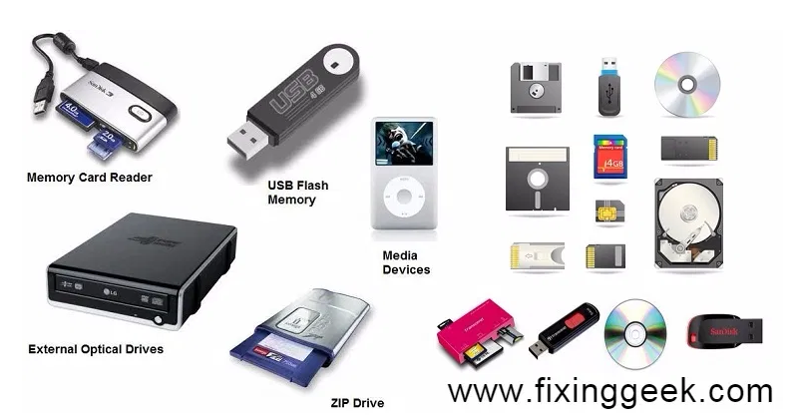

**1.4.6 . COMPUTER PORTS**

**1.4.6.1 WHAT IS MEANT BY A PORT?**

A port in a computer network is a communication endpoint whereas, in an operating system, it is a logical construct, recognizes precise method otherwise a network service type. These endpoints recognize the combination of every protocol and its address through 16-bit unsigned numbers, called the port number. The protocols that use port numbers are the TCP (Transmission Control Protocol) and UDP (User Datagram Protocol). The port number in every computer networking uses an IP address of the type of protocol & the host

**1.4.6.2 What is Port in Computer/Computer Port?**

A computer port or a communication port is a connection point used as an interface between the computer & the peripherals like keyboard, mouse, printer, display unit, monitor, flash drive and speaker. The computer port transmits the data from any peripheral to the computer. In general, the communication ports are available in two type like Serial Ports as well as Parallel Ports.

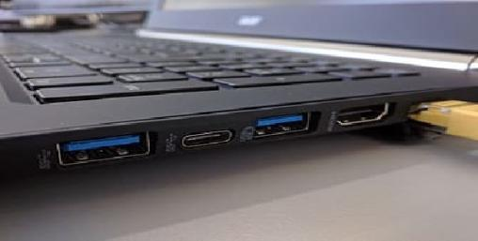

**1.4.6.3 Characteristics of Computer Ports**

The characteristics of the computer port include the following.

* It is an interface between external devices as well as a computer.
* Ports on the motherboard can be connected using an external device cable by plugging in.
* The external devices which are connected through via ports are the keyboard, mouse, microphone, monitor, speakers, etc.

**1.4.6.4**  **Types of Computer Ports**

There are different types of ports available in a computer network. Some of them are:

* PS/02
* Serial Port
* Parallel Port
* Ethernet
* VGA Port
* USB Port
* DVI Port
* HDMI Port
* Display Port

**1.4.6.4.1 PS/2 PORTS:** PS/2 is a type of [port](https://techterms.com/definition/port) used by older computers for connecting [input devices](https://techterms.com/definition/inputdevice) such as [keyboards](https://techterms.com/definition/keyboard) and [mice](https://techterms.com/definition/mouse). The port was introduced with IBM's Personal System/2 computer in 1987 (which was abbreviated"PS/2").The PS/2 port has six pins and is roughly circular in shape

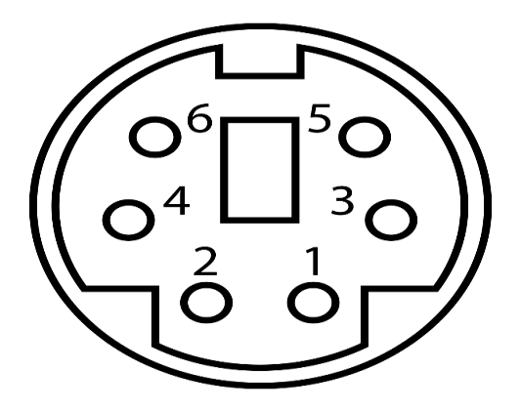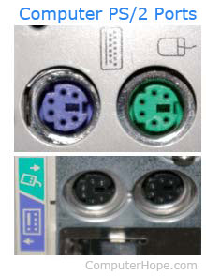

**1.4.6.4.2 SERIAL PORT:** A serial port is an interface that allows a PC to transmit or receive data one bit at a time. It is one of the oldest types of interfaces commonly used to connect printers and external modems to a PC. Compared to a parallel port, the data transfer rate of a serial port is slower. Normally, a serial port is a male port, while a parallel port is a female port. The serial port standard is RS-232. This standard is used for transmitting serial communication between devices,



**1.4.6.4.3 PARALLEL PORT: Parallel port** is a type of interface found on computers (personal and otherwise) for connecting peripherals. Parallel ports send multiple bits of data at once (parallel communication), as opposed to serial communication, in which bits are sent one at a time. Parallel port is an interface between computer and peripheral devices like printers with parallel communication

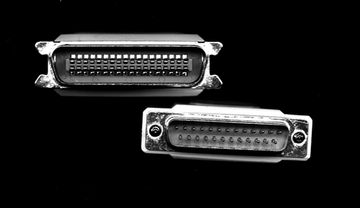

**1.4.6.4**.**4 ETHERNET:** A Ethernet port is a jack or socket on a computer that allows the use of an Ethernet connector. These ports are essential in allowing the creation of local area networks (LANs). An Ethernet port is usually found on networking devices, including computers, routers, video game consoles, modems, and televisions. Ethernet is a communication system that allows multiple local devices to share information and work together.

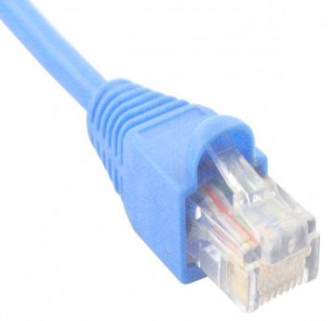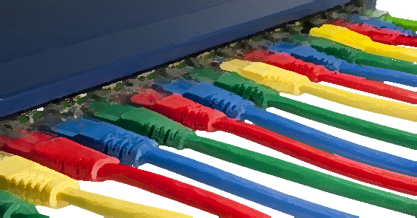

**1.4.6.4.5 VGA PORT:** Abbreviated VGA, Video Graphics Array is a standard type of connection for video devices such as monitors and projectors. Generally, VGA refers to the types of cables, ports, and connectors used to connect monitors to video cards.

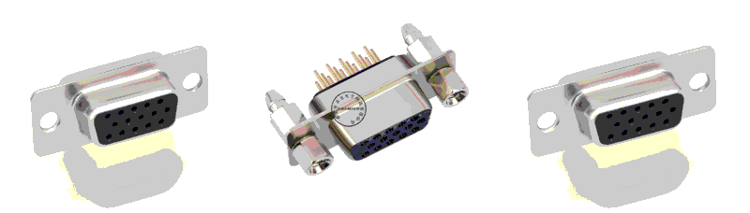.

**1.4.6.4.6 USB PORT:** A **USB port** is a standard cable connection interface for personal computers and consumer electronics devices. [USB stands for Universal Serial Bus](https://www.lifewire.com/universal-serial-bus-usb-2626039), USB ports allow USB devices to be connected to each other with and transfer digital data over USB cables

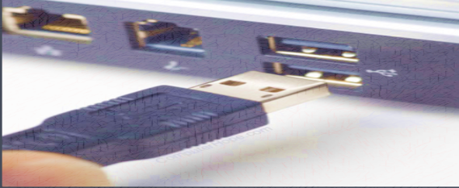

**1.4.6.4.7 HDMI PORT:** Full form of HDMI is **High-Definition Multimedia Interface.**

HDMI is a [proprietary](https://en.wikipedia.org/wiki/Proprietary_hardware) audio/video [interface](https://en.wikipedia.org/wiki/Interface_(computing)) for transmitting [uncompressed video](https://en.wikipedia.org/wiki/Uncompressed_video) data and compressed or uncompressed [digital audio](https://en.wikipedia.org/wiki/Digital_audio) data from an HDMI-compliant source device, such as a [display controller](https://en.wikipedia.org/wiki/Display_controller), to a compatible [computer monitor](https://en.wikipedia.org/wiki/Visual_display_unit), [video projector](https://en.wikipedia.org/wiki/Video_projector), [digital television](https://en.wikipedia.org/wiki/Digital_television), or [digital audio](https://en.wikipedia.org/wiki/Digital_audio) device..

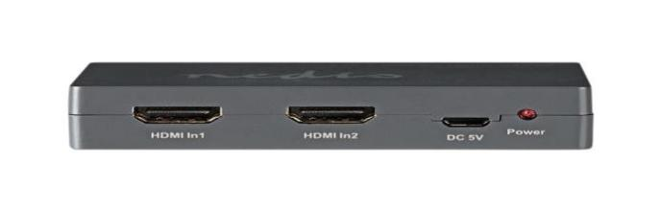

**1.4.6.4**.**8 DISPLAY PORT**: DisplayPort is a digital display interface developed by a consortium of PC and chip manufacturers and standardized by the Video Electronics Standards Association. Display Port is a digital display interface with optional multiple channel audio and other forms of data. Display Port is developed with an aim of replacing VGA and DVI ports as the main interface between a computer and monitor.

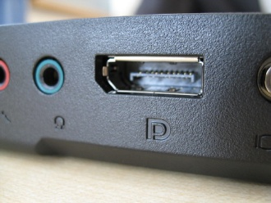

***EXPERIMENT -2***

***2.1. Linux commands***



Q1. Create the directories and files as given in the above directory structure. Directories are mentioned as (d). Files should be filled with necessary text data

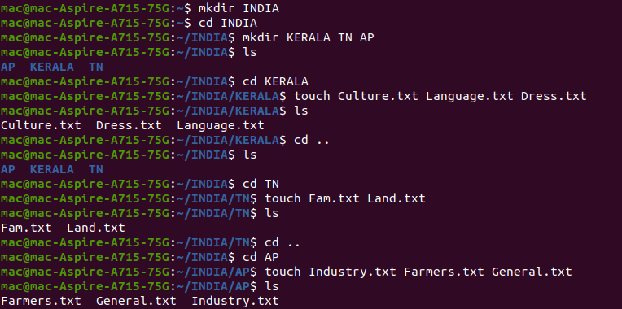



Q2. List your present working directory



Q3. Move to the root directory.



Q4. Copy the file ‘Culture’ to the folder AP

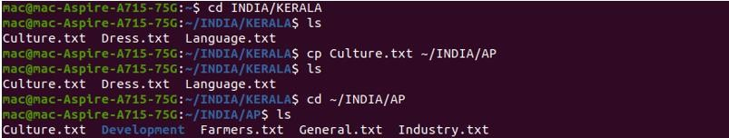

Q5. Display the content of the file ‘general’

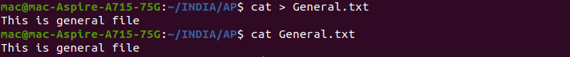

Q6. Move the file ‘language’ to the directory AP/Development

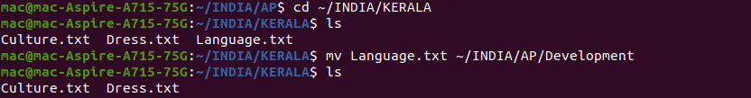

Q7. List all the files in the folder AP

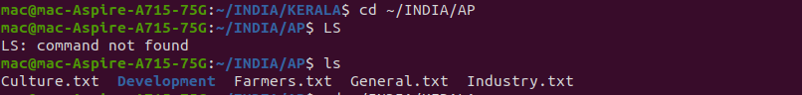

Q8. List first 10 lines of the file ‘Dress’

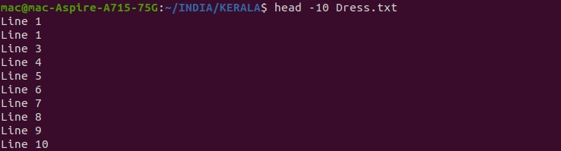

Q9. List the last 10 lines of the file ‘Dress’

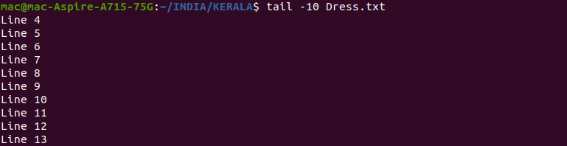

Q10. List all the files in AP in long listing format

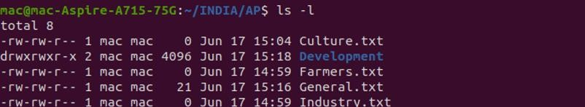

Q11. List the files in AP which begin with the character ‘f’



Q12. List the files page by page

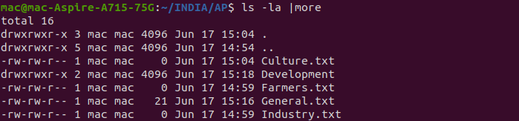

Q13. Remove the file ‘general’



Q14. Change the permission of the file ‘Culture’ as only read permission to all



Q15. List the lines of the file which contains a string ‘Saree’

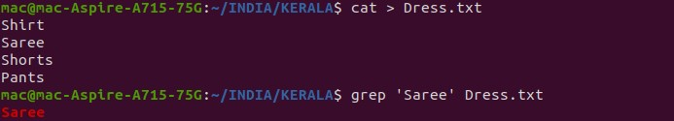

Q16. Use man command to get the syntax of ***wc*** command

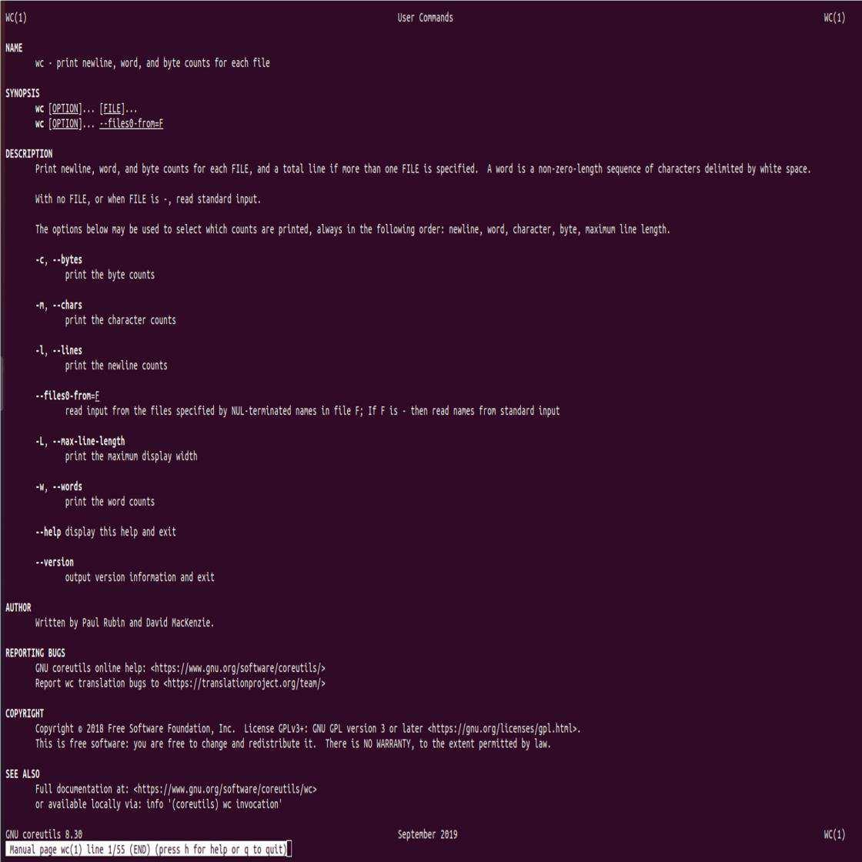

Q17. Count the number of characters, words, lines in the directory listing



Q18. Put a listing of the files in your directory into a file called ***filelist.***

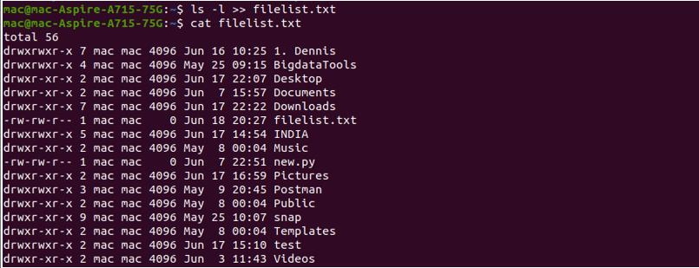

Q19. List the status of all process running in your system

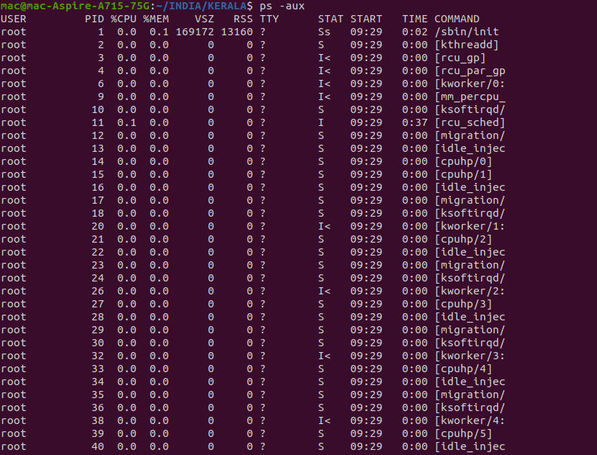

Q20. List the disk partitions in your harddisk.

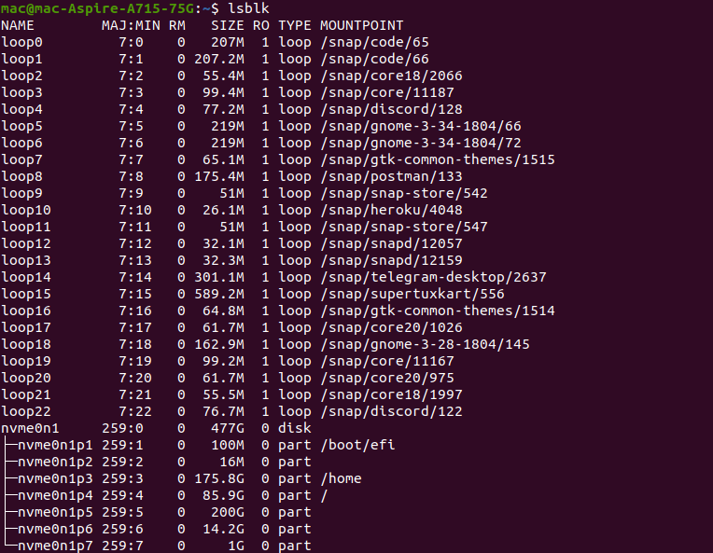

Q21. Redirect the output of the ***top*** program to a file called ‘errors’.

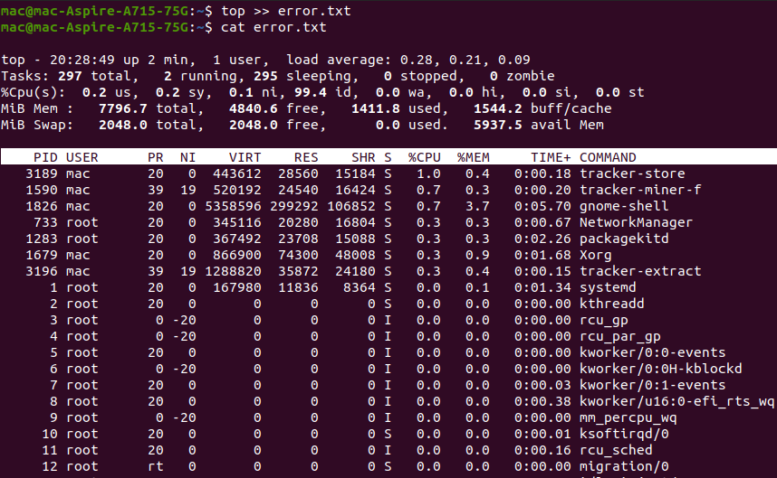

**Experiment 3**

**3.1. Linux File System Hierarchy Structure:**

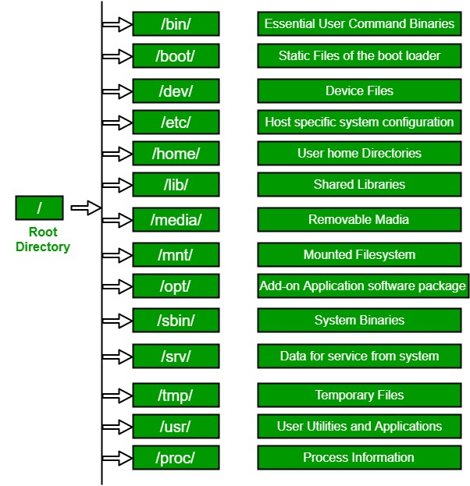

The Linux File System Hierarchy defines the directory structure and directory contents in Unix-like operating systems. It is maintained by the Linux Foundation.

* The all files and directories appear under the root directory /, even if they are stored on different physical or virtual devices.
* Most of these directories exist in all UNIX operating systems and are generally used in much the same way; however, the descriptions here are those used specifically for the FHS and are not considered authoritative for platforms other than Linux.
* Most [Linux distributions](https://en.wikipedia.org/wiki/Linux_distribution) follow the Filesystem Hierarchy Standard and declare it their own policy to maintain FHS compliance.

* Some distributions generally follow the standard but deviate from it in some areas. The FHS is a "trailing standard", and so documents common practices at a point in time.

**3.2. The tree intallation process:**

* Install tree using the following command:

**$ sudo apt install tree**

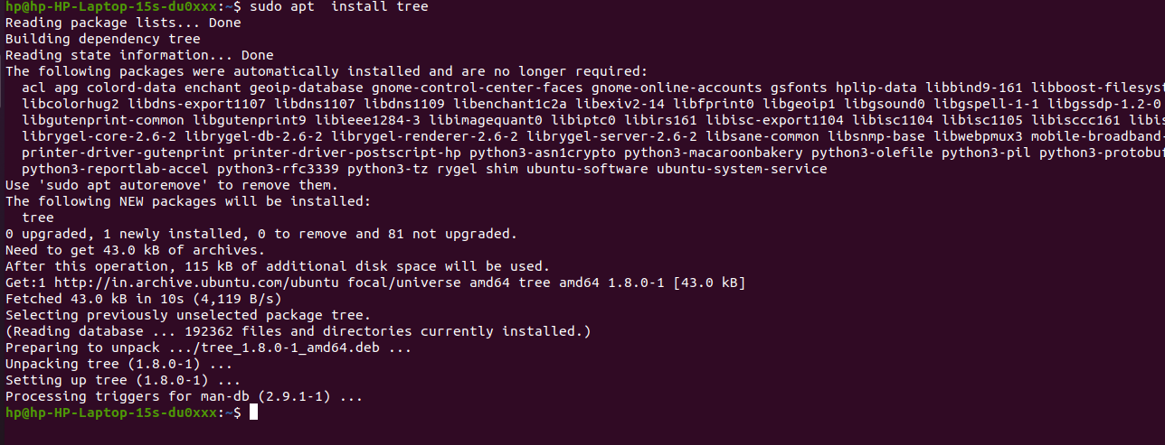

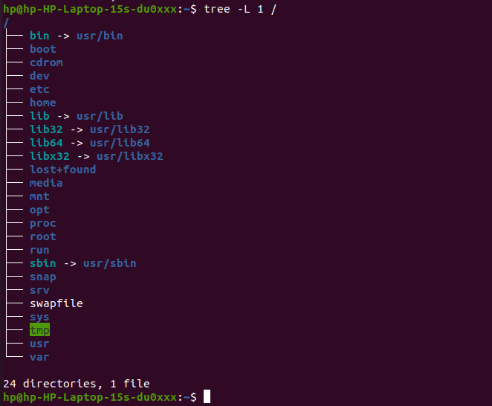

* Explore various directories and files using the command cd, ls etc in linux and provide its screenshots

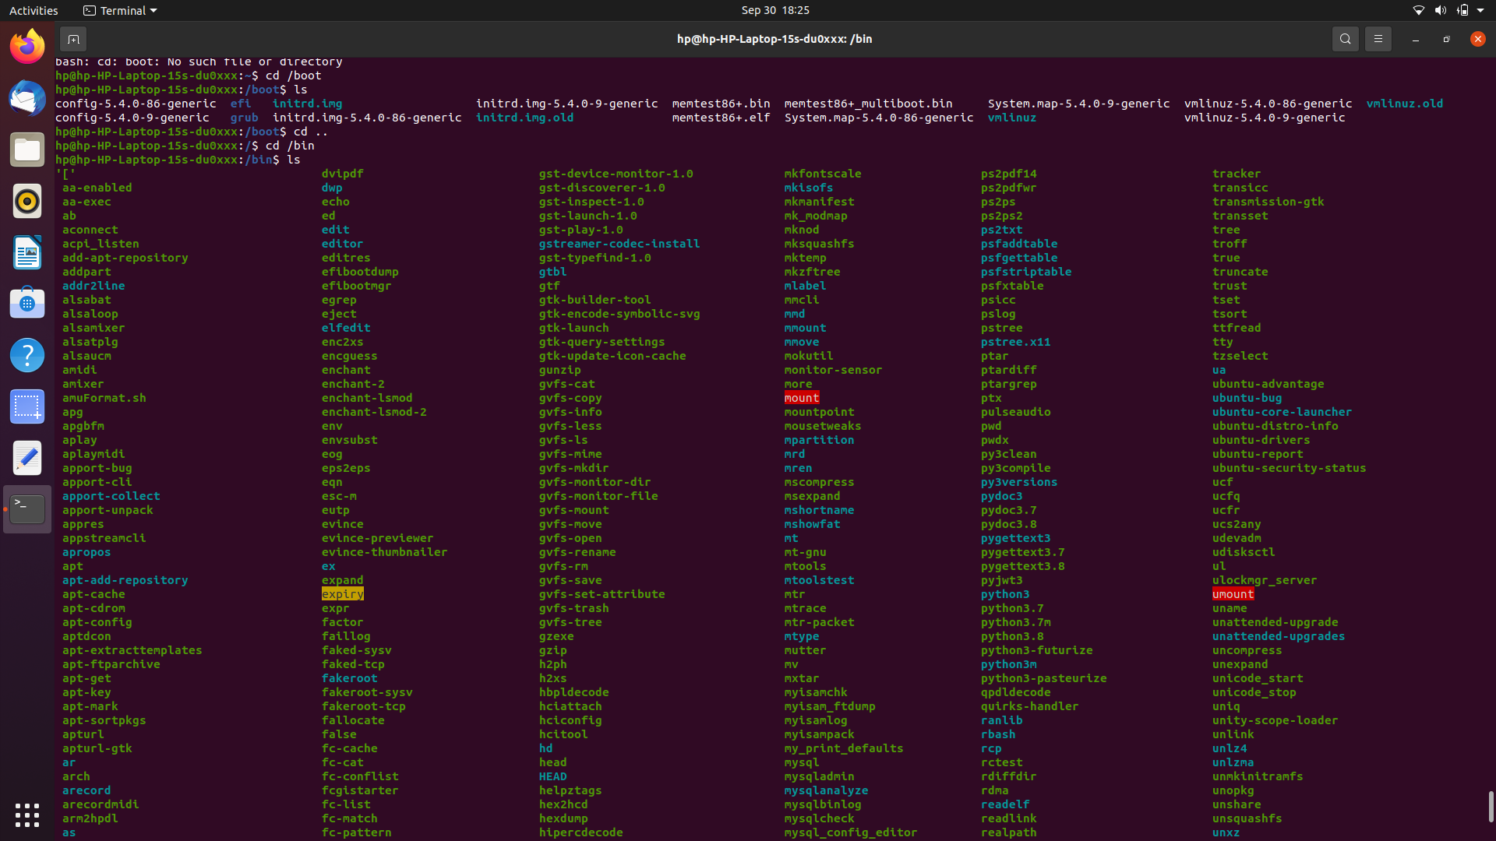

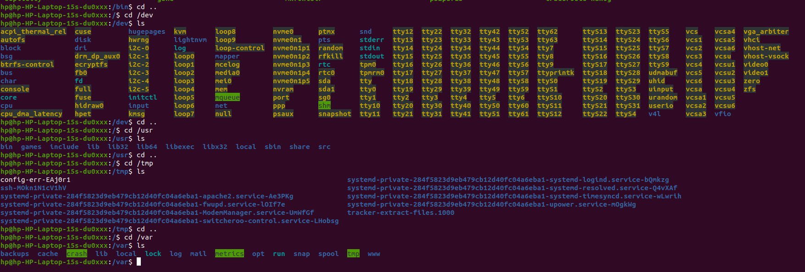

**3.3. The detailed explanation of directories in Linux**

**1. / (Root):**Primary hierarchy root and root directory of the entire file system hierarchy. 

* Every single file and directory starts from the root directory
* The only root user has the right to write under this directory
* /root is the root user’s home directory, which is not the same as /

**2. /bin :**Essential command binaries that need to be available in single-user mode; for all users, e.g., cat, ls, cp. 

* Contains binary executables
* Common linux commands you need to use in single-user modes are located under this directory.
* Commands used by all the users of the system are located here e.g. ps, ls, ping, grep, cp

**3. /boot :**Boot loader files, e.g., kernels, initrd. 

* Kernel initrd, vmlinux, grub files are located under /boot
* Example: initrd.img-2.6.32-24-generic, vmlinuz-2.6.32-24-generic

**4. /dev :**Essential device files, e.g., /dev/null.

* These include terminal devices, usb, or any device attached to the system.
* And also know the connected devices.

**5. /etc :**Host-specific system-wide configuration files.

* Contains configuration files required by all programs.
* This also contains startup and shutdown shell scripts used to start/stop individual programs.
* Example: /etc/resolv.conf, /etc/logrotate.conf.
* The old format is et cetera

**6. /home :**Users’ home directories, containing saved files, personal settings, etc.

* Home directories for all users to store their personal files.

**7. /lib :**Libraries essential for the binaries in /bin/ and /sbin/.

* Library filenames are either ld* or lib*.so.*
* Eg wifi,printer etc

**8. /media :**Mount points for removable media such as CD-ROMs (appeared in FHS-2.3).

* Temporary mount directory for removable devices.
* Examples, /media/cdrom for CD-ROM; /media/floppy for floppy drives; /media/cdrecorder for CD writer

**9. /mnt :**Temporarily mounted filesystems.

* Temporary mount directory where sysadmins can mount filesystems.

**10. /opt :**Optional application software packages.

* Contains add-on applications from individual vendors.
* Add-on applications should be installed under either /opt/ or /opt/ sub-directory.

**11. /sbin :**Essential system binaries, e.g., fsck, init, route.

* Just like /bin, /sbin also contains binary executables.
* The linux commands located under this directory are used typically by system administrator, for system maintenance purpose.
* Example: iptables, reboot, fdisk, ifconfig, swapon

**12. /srv :**Site-specific data served by this system, such as data and scripts for web servers, data offered by FTP servers, and repositories for version control systems.

* srv stands for service.
* Contains server specific services related data.
* Example, /srv/cvs contains CVS related data.

**13. /tmp :**Temporary files. Often not preserved between system reboots, and may be severely size restricted.

* Directory that contains temporary files created by system and users.
* Files under this directory

**14. /usr :**Secondary hierarchy for read-only user data; contains the majority of (multi-)user utilities and applications.

* Contains binaries, libraries, documentation, and source-code for second level programs.
* /usr/bin contains binary files for user programs. If you can’t find a user binary under /bin, look under /usr/bin. For example: at, awk, cc, less, scp
* /usr/sbin contains binary files for system administrators. If you can’t find a system binary under /sbin, look under /usr/sbin. For example: atd, cron, sshd, useradd, userdel
* /usr/lib contains libraries for /usr/bin and /usr/sbin
* /usr/local contains users programs that you install from source. For example, when you install apache from source, it goes under /usr/local/apache2
* /usr/src holds the Linux kernel sources, header-files and documentation.

**15. /proc :**Virtual filesystem providing process and kernel information as files. In Linux, corresponds to a procfs mount. Generally automatically generated and populated by the system, on the fly.

* Contains information about system process.
* This is a pseudo filesystem contains information about running process. For example: /proc/{pid} directory contains information about the process with that particular pid.
* This is a virtual filesystem with text information about system resources. For example: /proc/uptime

## 16. /var — Variable Data Files

The /var directory is the writable counterpart to the /usr directory, which must be read-only in normal operation. Log files and everything else that would normally be written to /usr during normal operation are written to the /var directory. For example, you’ll find log files in /var/log.

## 17./srv — Service Data

The /srv directory contains “data for services provided by the system.” If you were using the Apache HTTP server to serve a website, you’d likely store your website’s files in a directory inside the /srv directory.

**18./run — Application State Files**

The /run directory is fairly new, and gives applications a standard place to store transient files they require like sockets and process IDs. These files can’t be stored in /tmp because files in /tmp may be deleted.

**EXPERIMENT-04**

**4.1. Shell Script**

**1. Write a Shell program to display a given message**

Shell code:

echo "Enter a message"

read msg

echo "The given message is :$msg"

Output :

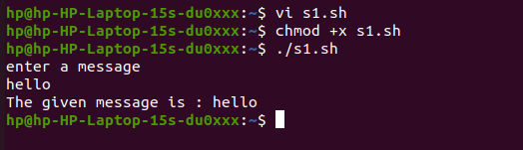

**Result:**

The program exicute succesfully

**2. Write a shell script to evaluate arithmetic operations.**

Shell code:

echo “enter two integer number”

read a

read b

c=`expr $a + $b`

echo “sum of two numbers=$c”

c=`expr $a - $b`

echo “Differents of two numbers=$c”

c=`expr $a / $b`

echo “division of two numbers=$c”

c=`expr $a \* $b`

echo “multiplication of two numbers=$c”

c=`expr $a % $b`

echo “remainder=$c”

**Output:**

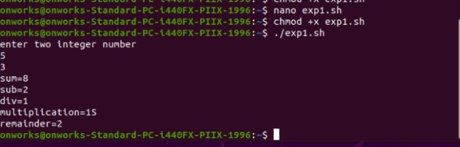

**Result:**

The program exicute succesfully

**3. Write a shell Script to determine largest among three integer number**

Shell code:

echo “enter three integer number”

read a

read b

read c

if [ $a -gt $b ] && [ $a -gt $c ]

then

echo “$a is largest number”

elif [ $b -gt $a ] && [ $b -gt $c ]

then

echo “$b is largest number”

else

echo “$c is largest number”

fi

Output:

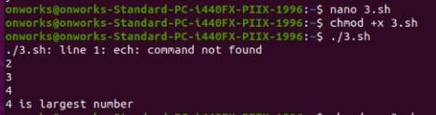

**Result:**

The program exicute succesfully

**4. Write a shell script to compare two string**

Shell code:

echo “enter two string”

read a

read b

if [ -z $a ]

then

echo “ First String is empty: Null String”

fi

if [ -z $b ]

then

echo “ First String is empty: Null String”

fi

if [ $a = $b ]

then

echo “Strings are equal: strings Matched”

else

echo “Strings are not equal: Strings not match”

fi

Output:

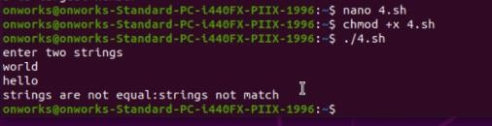

**Result:**

The program exicute succesfully

**5. Write a shell script to read and check the directory exists or not, if not make directory**

Shell code:

echo “enter name of directory”

read dir

if [ -d $dir ]

then

echo “Directory $dir Exits!”

else

mkdir $dir

fi

Output:

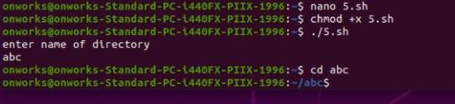

**Result:**

The program exicute succesfully

**6. Write a shell script to read and check the file exists or not, if not make file.**

Shell code:

echo “enter name of file”

read filename

if [ -f $filename ]

then

echo “File $filename Exits!”

else

touch $filename

fi

Output:

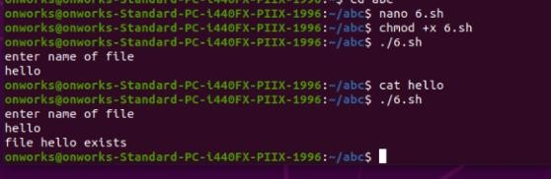

**Result:**

The program exicute succesfully

**7. Write a shell script to implement menu driven program to perform all arithmetic operation using case statement.**

Shell code:

echo “enter two integer values”

read a

read b

echo " Menu"

echo "1->Addition"

echo "2->Substraction"

echo "3->Multiplication"

echo "4->Division"

echo "5->Remainder "

echo “enter choice”

read ch

case $ch in

1) echo “Sum=$(expr $a + $b)”;;

2) echo “Substraction=$(expr $a - $b)”;;

3) echo “Multiplication=$(expr $a \* $b)”;;

4) echo “Division=$(expr $a / $b)”;;

5) echo “Remainder=$(expr $a % $b)”;;

6) echo “invalid Choice:Try Again!”

Esac

Output:

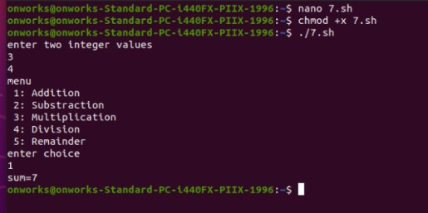

**Result:**

The program exicute succesfully

**8. Write a shell script to do:**

**a. display list of directory contents**

**b. Name of current directory**

**c. Who is logged on**

**d. Long listing of directory contents according to choose of user.**

Shell code:

echo " Menu"

echo " 1-> listing directory content"

echo " 2-> print name of current directory"

echo " 3-> Show who is logged on "

echo " 4-> Show directory content using long listing format "

echo "enter your choice "

read ch

case $ch in

1) ls;;

2) pwd;;

3) who;;

4) ls –l;;

*) echo “Invalid Choice: Try Again!!”

esac

Output:

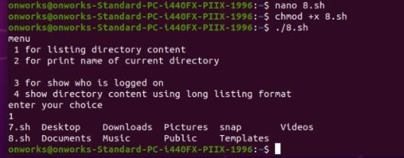

**Result:**

The program exicute succesfully

**9. Write a shell script to getting input details like name, roll number and marks and print them using command line arguments.**cat

shell code:

echo "Name of the student: $1"

echo "Roll Number of the student: $2"

echo "Marks of the student: $3"

Output:

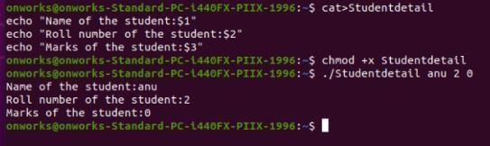

**Result:**

The program exicute succesfully

**10. Understand the differences between Echo statement using single quote , double quote and without quotes.**

Shell code:

a=12

echo $a

echo "$a"

echo '$a'

Output:

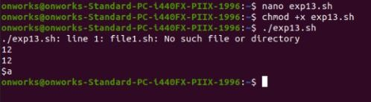

**Result:**

The program exicute succesfully

**11. To check whether there is any entry in the month of May in the system log.**

Shell code:

if [[ -e /var/log/syslog ]]

then

cat /var/log/syslog | grep "^May"

else

echo "File not found"

fi

Output:

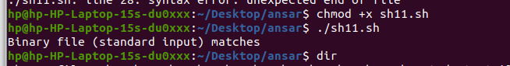

**Result:**

The program exicute succesfully

**12. Implement arithmetic calculator using Functions**

Shell code:

add()

{

i=$1

j=$2

k=$(($i+$j))

echo "Sum is $k"

}

sub()

{

i=$1

j=$2

((k=i-j))

echo "different is $k"

}

mul()

{

i=$1

j=$2

((k=i*j))

echo "product is $k"

}

echo "Enter your option: 1: Add, 2:Subtract, 3: Multiply"

read i

case $i in

1) add 11 2;;

2) sub 10 5;;

3) mul 1 2;;

esac

Output:

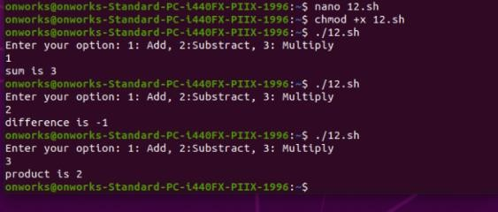

**Result:**

The program exicute succesfully

**13. To find the sum of n natural numbers.**

**a. Using for loop**

shell code:

sum=0

for ((i=0;i<10;i++))

do

((sum=sum+i))

done

echo $sum

Output

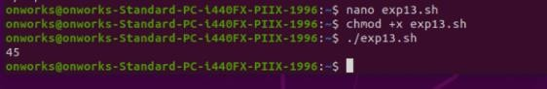

**b. Using While loop**

shell code:

i=0

sum=0

while ((i<10));do

((sum=sum+i))

((i=i+1))

done

echo $sum

Output:



**Result:**

The program exicute succesfully

**EXPERIMENT-05**

**5.1 Installing LAMP on Ubuntu**

### Step 1: Update Package Repository Cache

Before you begin:

1. Open the terminal either by using the **CTRL+ALT+T**keyboard shortcut or by searching for the word terminal in **Ubuntu**

2. Make sure to update the package repository cache to ensure it installs the latest versions of the software. To do so, type in the following command:

**sudo apt-get update**

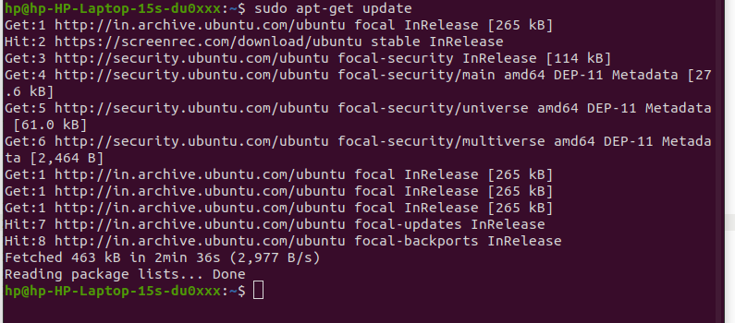

### Step 2: Install Apache

1. To install Apache, run the following command in the terminal:

**sudo apt-get install apache2**

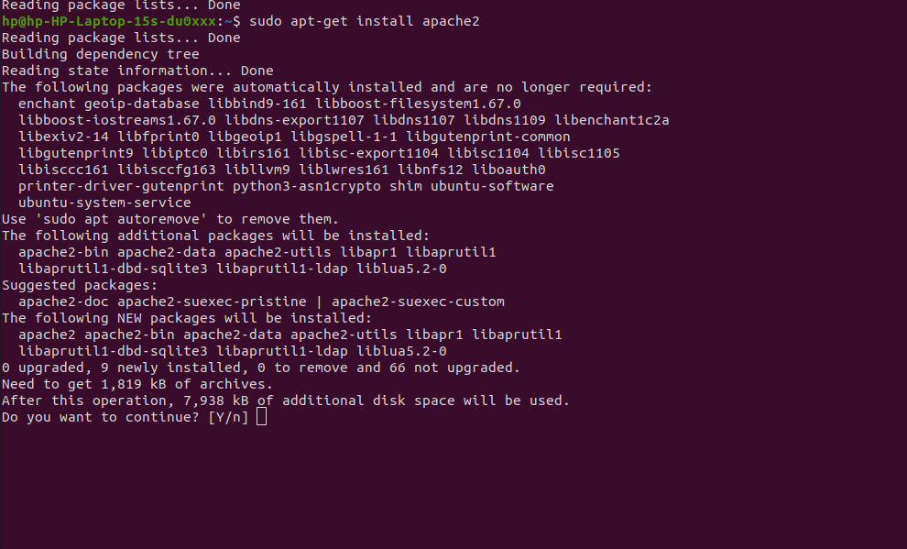

Press **y**(yes) and hit **ENTER**to permit the installation.

2. To ensure Apache is running, enter the Localhost of your server in the address bar and press **ENTER**.

The test Apache web server page should display as below.

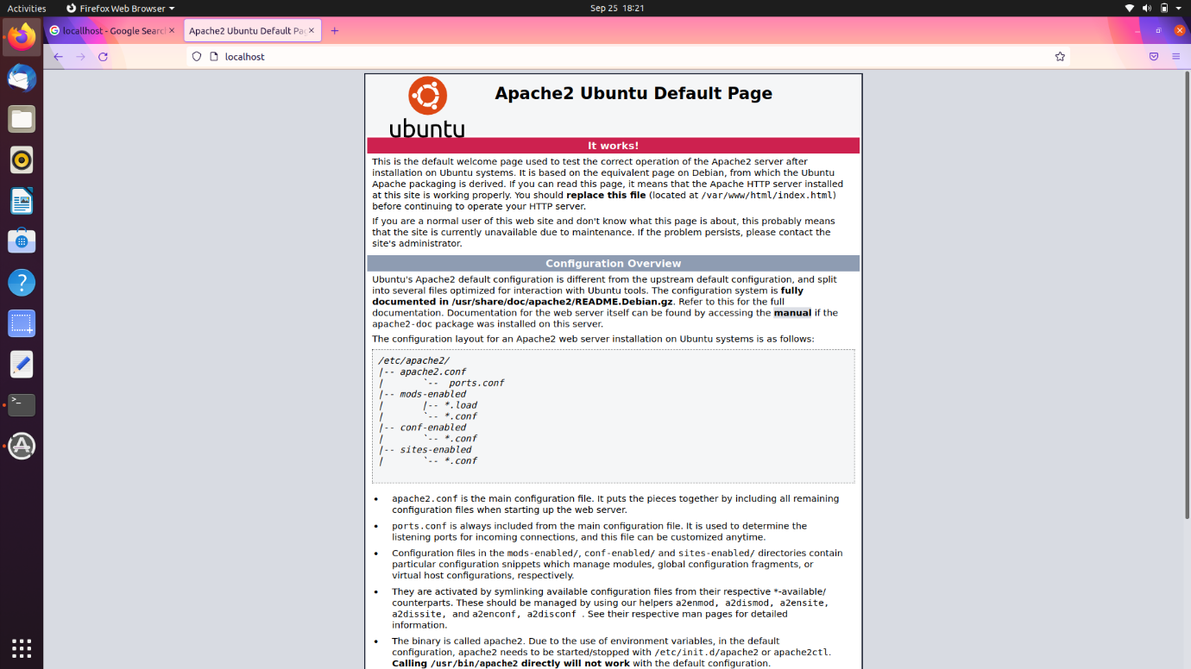

### Step 3: Install PHP

1. To install PHP, run the following command:

**$ sudo apt-get install php7.4**

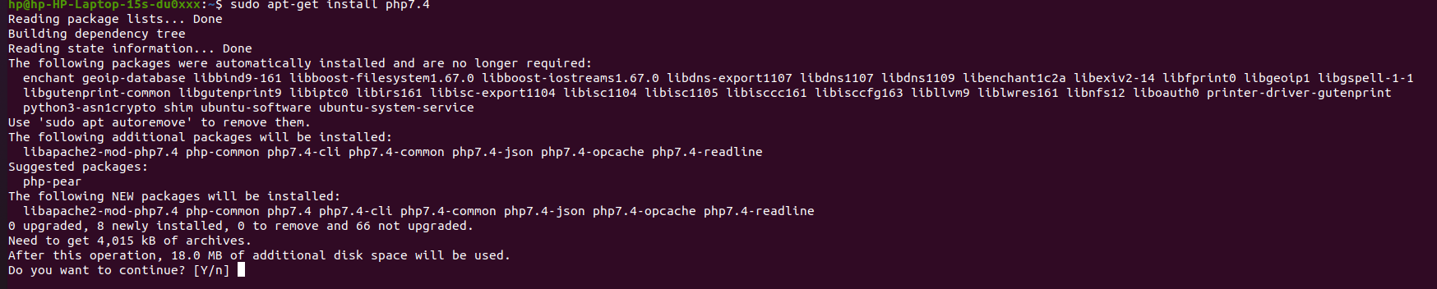

Press **y**and **ENTER** to allow the installation.

### Step 4: Restart Apache

After the php installation you must restart the Apache service.

Enter the command:

**$ sudo /etc/init.d/apache2 restart**

### Step 5: Test PHP Processing on Web Server

1. Create a basic **PHP script** and save it to the “web root” directory. This is necessary for Apache to find and serve the file correctly. This directory is located at **/var/www/html/**.

To create a file in that directory, type in the following command:

**sudo nano /var/www/html/test.php**

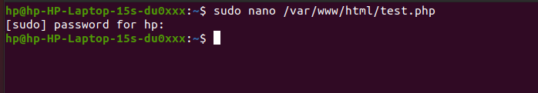

This command opens the **bank file**.

2. Inside the file, type in the valid PHP code:

**<?php**

**Echo “ test php ”;**

**?>**

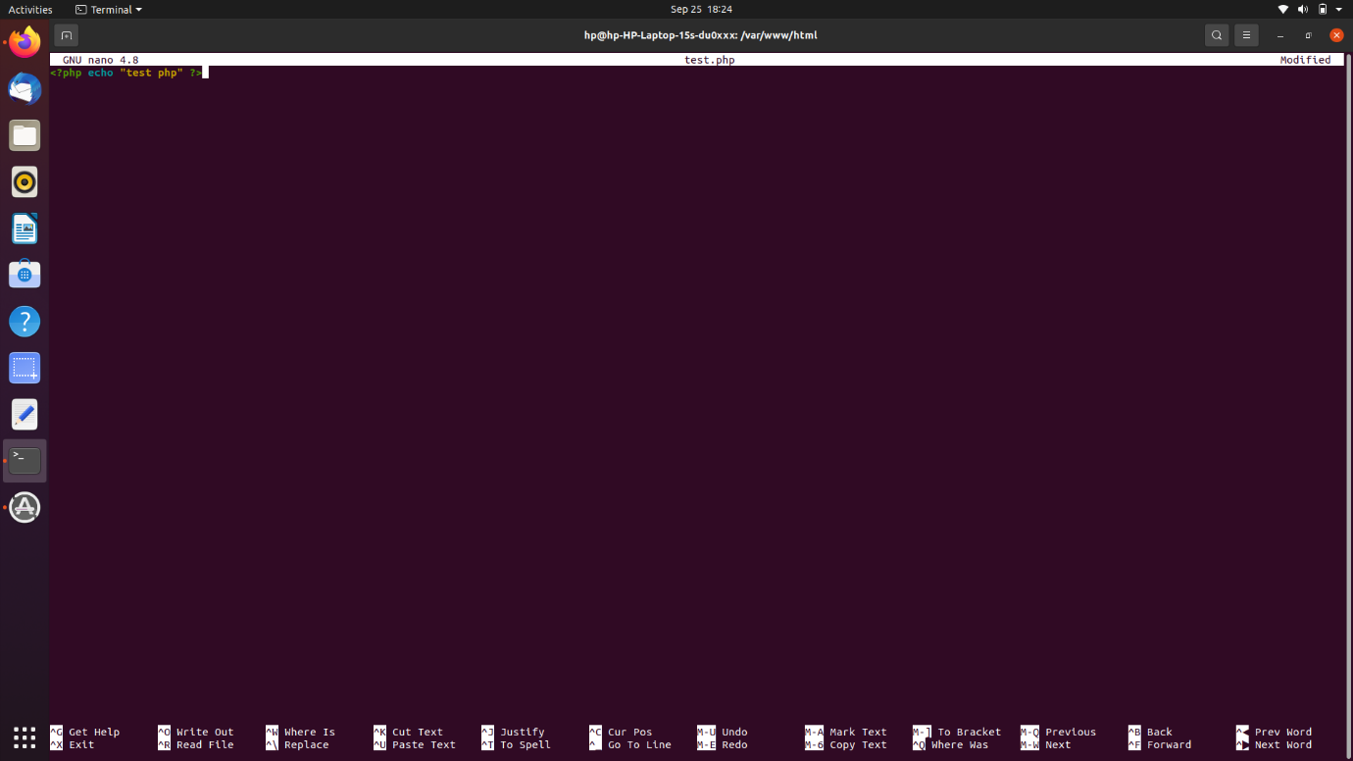

3. Press **CTRL + X** to save and close the file. Press **y** and **ENTER** to confirm.

4. Then check the code are run currectly in php.open the browser enter the

Ip address (localhost/test.php).

It show the below image

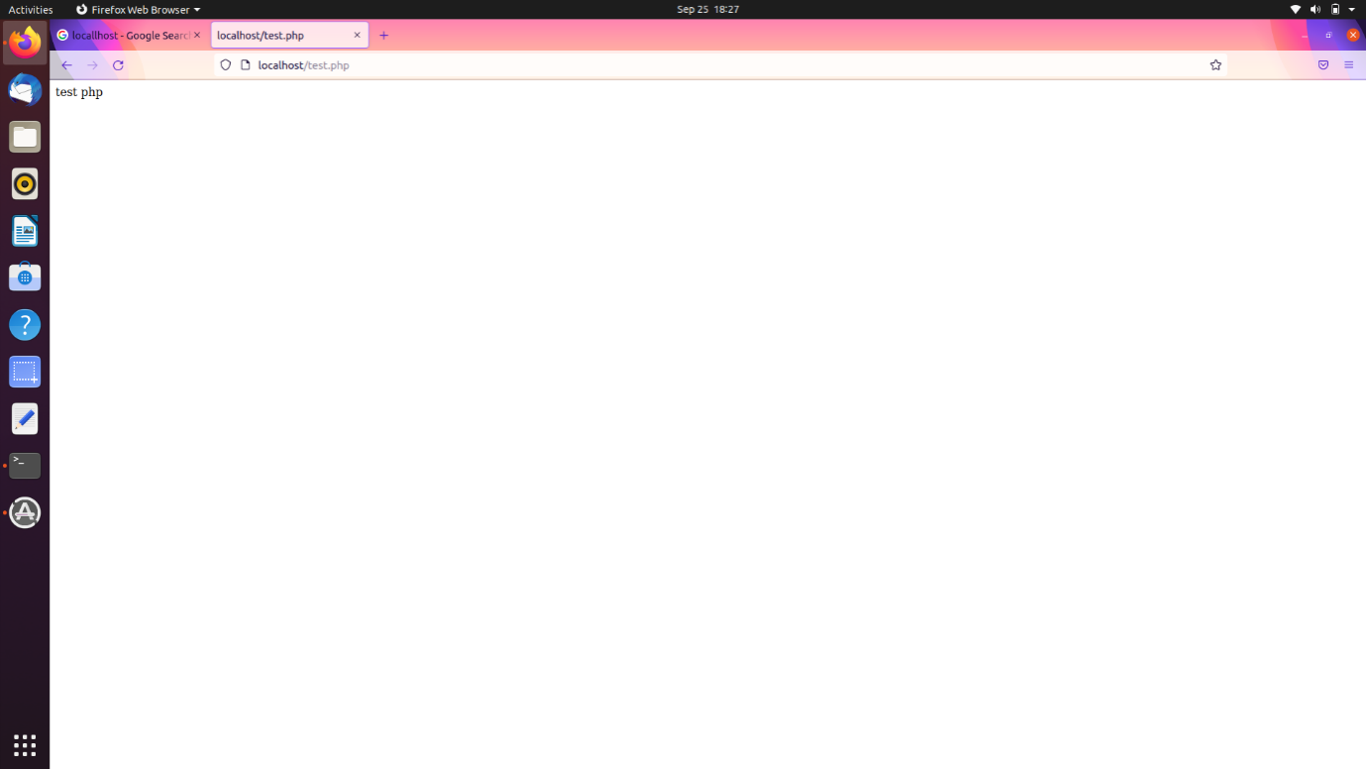

### Step 6: Install Mysql server

1. To install Mysql server, run the following command:

**$ sudo apt-get install mysql-server**

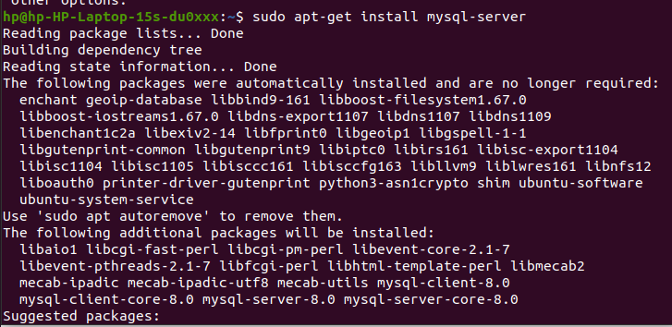

2.Then it’s asking us for a root password . enter the password . Again we get to repeat it

### Step 7: Check the Mysql server

1. To check Mysql server, run the following command

**$ mysql -u root -p**

* Enter the root password and press enter

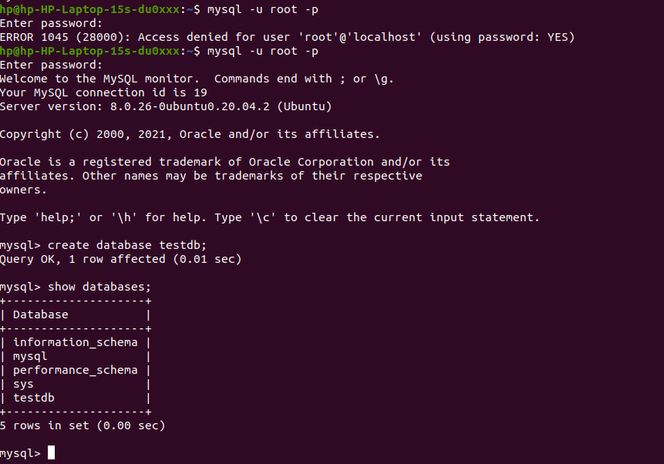

2 . Create a database testdb and show it

* Enter the command

Create database testdb;

Show databases;

* So mysql is working then exit the mysql prompt just enter **exit;**

### Step 8: Install PHP Myadmin

1. To install PHP Myadmin, run the following command:

**$ sudo apt-get install phpmyadmin**

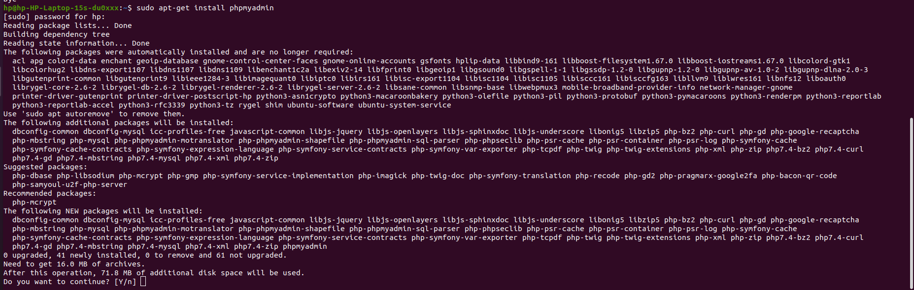

Press **y**and **ENTER** to allow the installation

1. Then its ask what type of server, we have Apache2 is set by default that’s what we want then press ok
2. Then a configuration prompt are open . here we’re going to just choose yes and then it ask the input password for phpmyadmin
3. Then check it currect . go to the localhost/phpmyadmin. Here we can not found it so

We have to actually edit the file php is located in Apache2 folder.

1. Enter the following command to edit the file

**$ sudo nano/etc/php7.4/apache2.php.ini**

1. Then we need to uncomment an **extension=mysql.so.** find it the file just remove the

Semicolon.

7.Then enter ctl+x to save

### Step 9: Restart Apache

After the php installation you must restart the Apache service.

Enter the command:

**$ sudo /etc/init.d/apache2 restart**

### Step 9.1:Include phpmyadmin in apache configuration

1. Enter the command:

**$ sudo nano/etc/apache2/apache2.conf**

1. Type the following command to the nano editor

**Include /etc/phpmyadmin/apache.conf**

3.Then enter ctl+x to save

4.Then again restart the apache

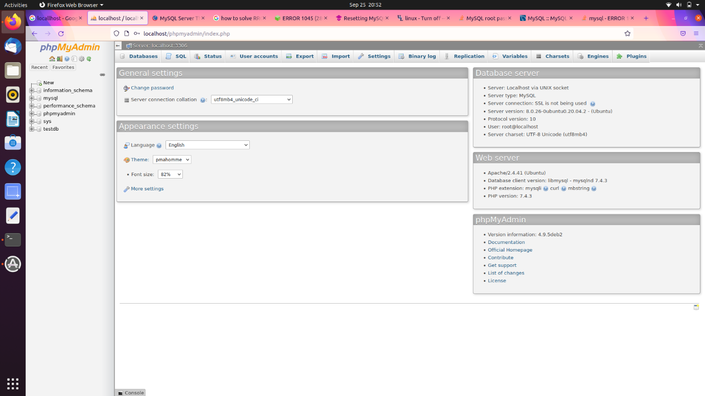

**EXPERIMENT-06**

**6.1.Laravel installation On Ubuntu with Apache**

### Step 1: Update Package Repository Cache

Before you begin:

1. Open the terminal either by using the **CTRL+ALT+T**keyboard shortcut or by searching for the word terminal in **Ubuntu**

2. Make sure to update the package repository cache to ensure it installs the latest versions of the software. To do so, type in the following command:

**sudo apt-get update**

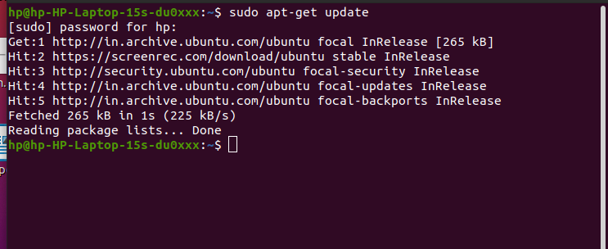

### Step 2: Install Apache

1. To install Apache, run the following command in the terminal:

**sudo apt-get install apache2**



2. To ensure Apache is running, enter the Localhost of your server in the address bar and press **ENTER**.

The test Apache web server page should display as below.



### Step 3: Install PHP

1. To install PHP, run the following command:

**$ sudo apt-get install php7.4**



Press **y**and **ENTER** to allow the installation

1. Then make a change in php init file . set cgi.fix_pathinfo set to be 0.Do it using the following commands.

* Cd /etc/php/ 7.4/apache2/
* Sudo nano php.ini
* It open the php.ini file ,then uncomment the line and it set to be 0

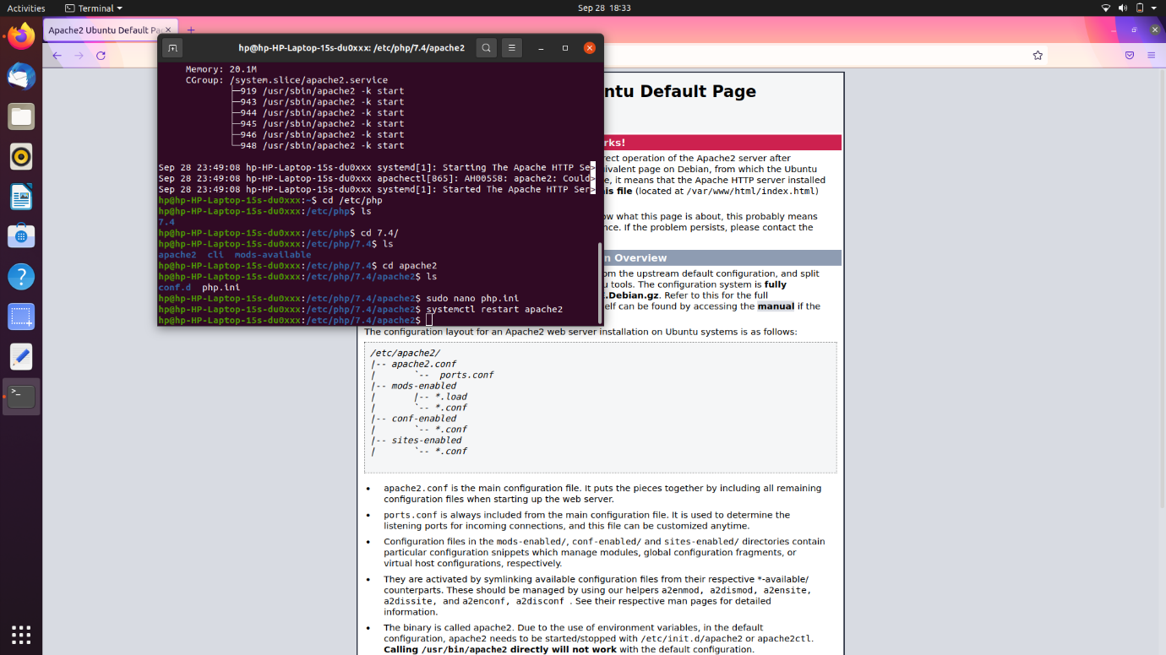

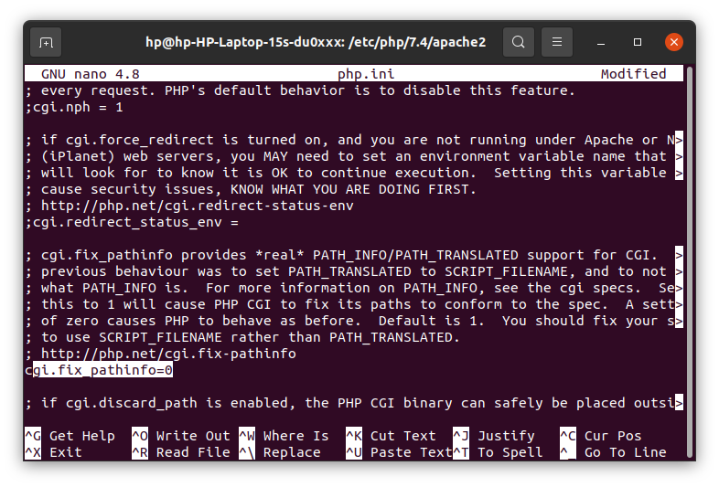

* Then restart the apache server using the following command

**$ systemctl restart apache**

### 4. Install Composer

Composer is a PHP dependency manager that facilitates the download of PHP libraries in our projects. Composer both works great with and makes it much easier to install Laravel.

1. Install composor using the following command

$ **Curl -sS** [**https://getcomposer**](https://getcomposer)**.org/installer | php**

1. In this time your system not insdtaaled the curl file .then install it using the following command

$ Sudo apt install curl

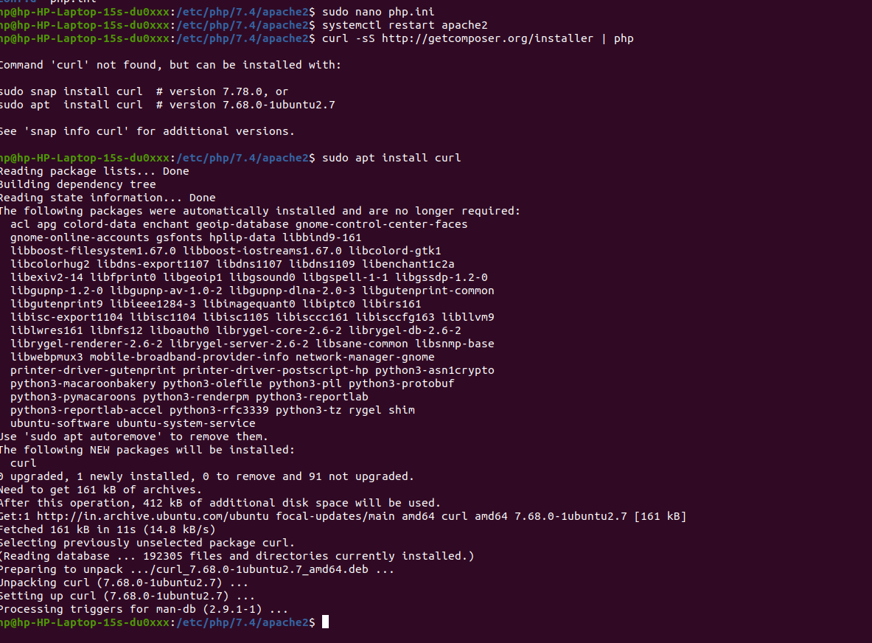

1. Move the file using the following command

**$ sudo mv composer.phar /usr/local/bin/composer**

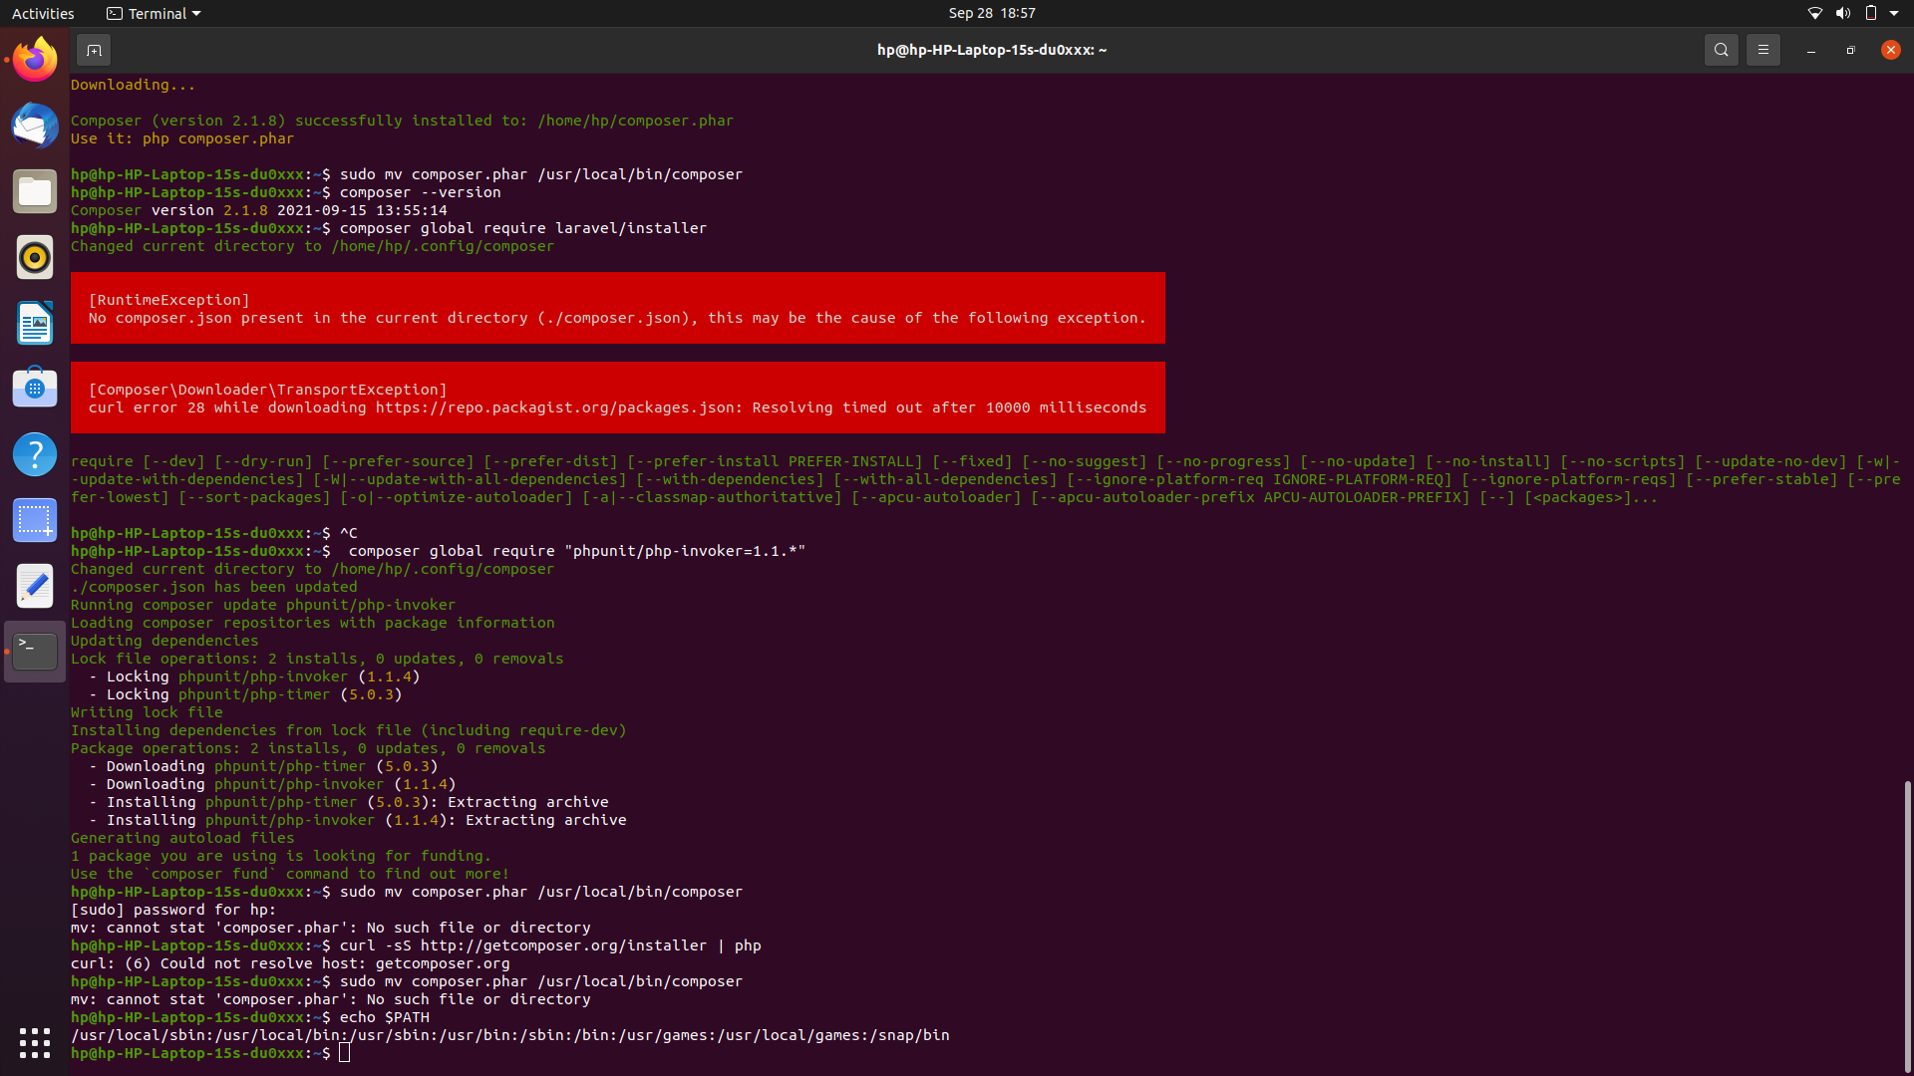

**Step 5 – Install Laravel 8.x on Ubuntu 20.04**

Now install Laravel Framework using composer, just type composer global require Laravel/installer It will take a while to complete download its dependencies

1. Lavaral install with following command

**$ composer global require laravel/installer**

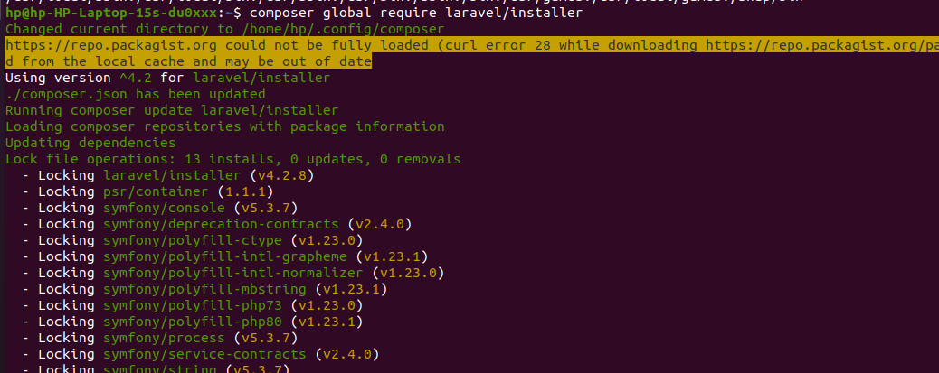

Next add bin directory to path environment through the~/.bashrc configuration .so edit the ~/.bashrc configuration using nano command. The command are follow

**$ nano ~/.bashrc**

**2.It open the file** and add the following line at the end of the file.

**export PATH="$HOME/.config/composer/vendor/bin:$PATH"**

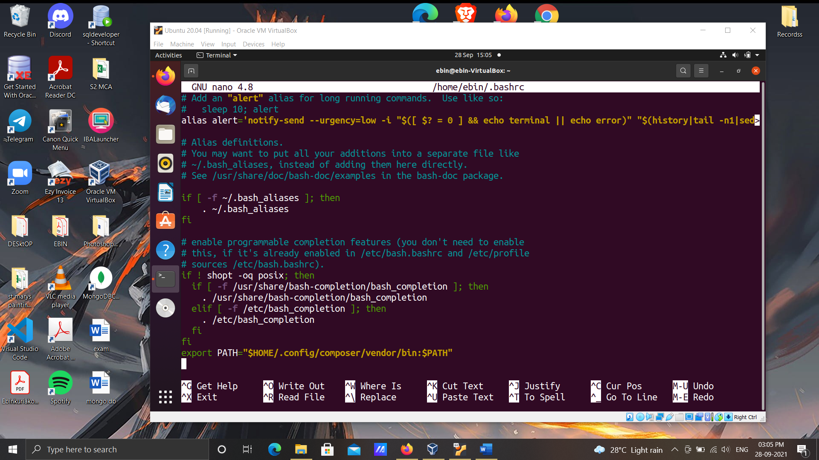

3.Then reload your bashrc configuration using the source command.

**$ source ~/.bashrc**

4.Then echo $PATH. It will return your “Bin” directory path for the Composer package.

**$ echo $PATH**

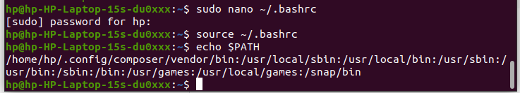

5.then create a new project in lavaral with the following command

**$ laravel new myapp1**

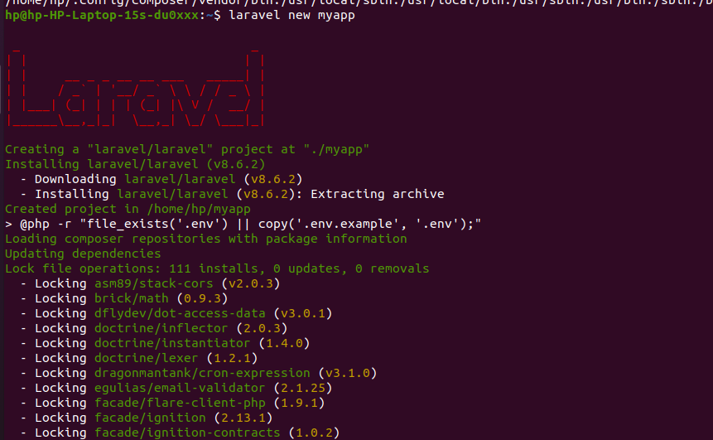

Here you can see the installation of my new project myapp1 finished. You can also see inside my home directory a new directory has been created with my project name.

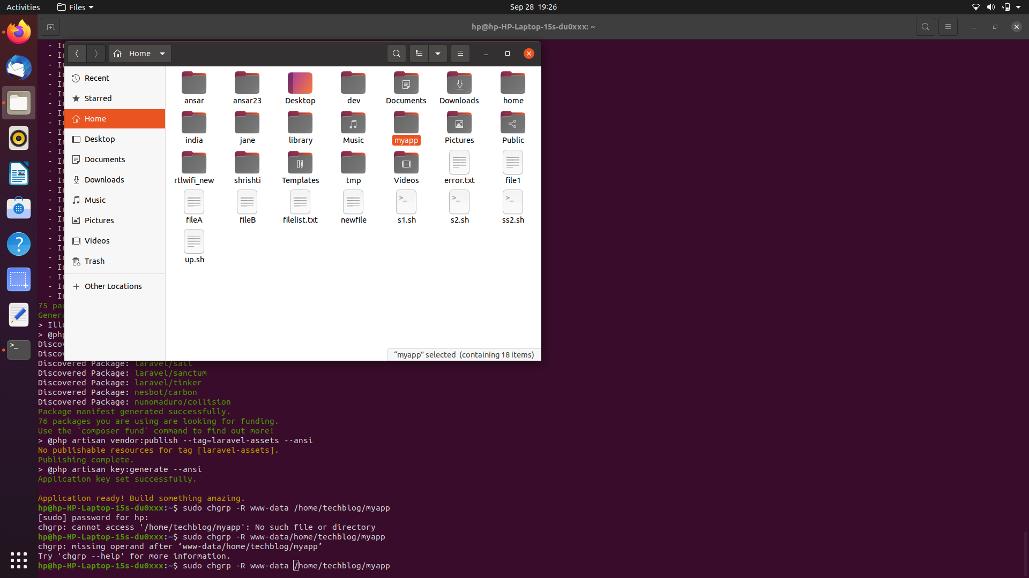

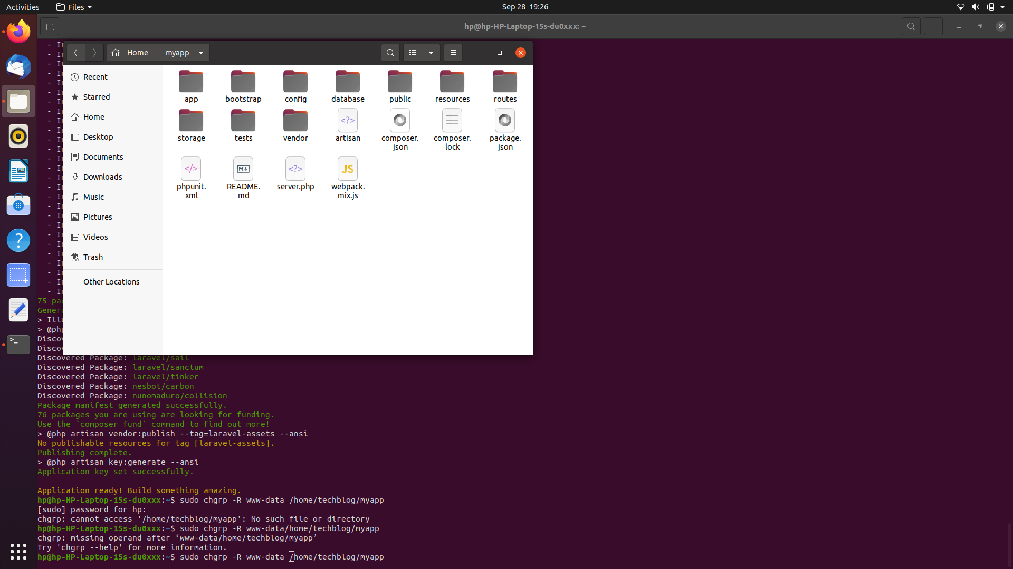

**Step 6– Finally Configure Apache for Laravel and test it**

**1.** First, add your project directory to www-data group use the following command

**$ sudo chgrp -R www-data /home/hp/myapp**

* Then you need to change access permission 775 of the storage directory under your project. use the following command.

**$ sudo chmod -R 775 /home/hp/myapp/storage**

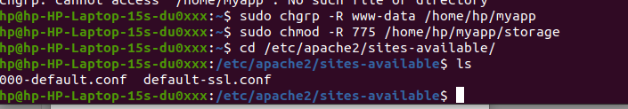

6.Then create an apache vhost configuration go to the following directory and create a vhost config file using nano file editor.

**$ cd /etc/apache2/sites-available/**

**$ sudo nano myapp1.com.conf**

And paste the following line inside the file.

<VirtualHost *:80>

ServerName myapp.com

ServerAdmin admin@myapp.com

DocumentRoot /home/hp/myapp/public

<Directory /home/hp/myapp>

Options Indexes MultiViews

AllowOverride None

Require all granted

</Directory>

ErrorLog ${APACHE_LOG_DIR}/error.log

CustomLog ${APACHE_LOG_DIR}/access.log combined

</VirtualHost>

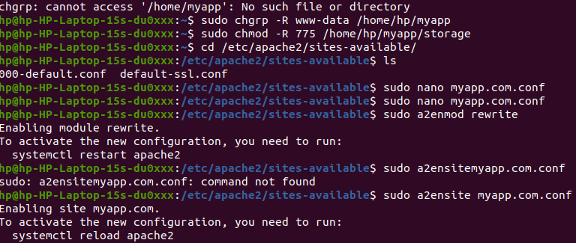

**7.** Now enable mod rewrite for apache2 just type

**$ sudo a2enmod rewrite**

Then enable your site, just type

**$ sudo a2ensite myapp1.com.conf**

Finally, Restart the apache service, type

**$ systemctl restart apache2**

**8.** As you are in a local environment you need a local dns resolver for your site. Go ahead and edit /etc/hosts file, add a dns record for your site then save the file.

**$ sudo nano /etc/hosts**

**Inside the file add the below line**

**127.0.0.1 myapp.com**

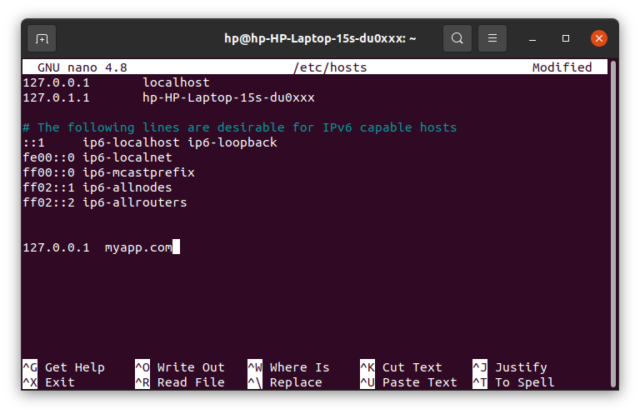

Now get back to the web browser and open a tab then type your project hostname.

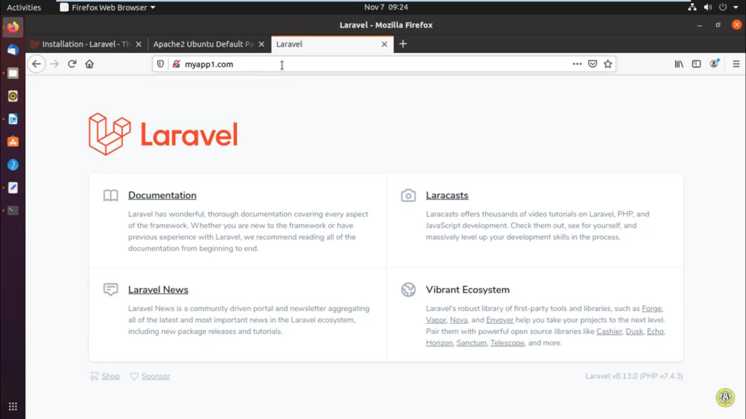

And here it is it’s working. Here you can see the Laravel version and PHP version.

**EXPERIMENT-07**

**7.1.Networking commands**

**7.1.1.PING COMMAND**

PING (Packet Internet Groper) command is used to check the network connectivity between host and server/host. This command takes as input the IP address or the URL and sends a data packet to the specified address with the message “PING” and get a response from the server/host this time is recorded which is called latency. Fast ping low latency means faster connection. Ping uses ICMP(Internet Control Message Protocol) to send an ICMP echo message to the specified host if that host is available then it sends ICMP reply message. Ping is generally measured in millisecond every modern operating system has this ping pre-installed.

Syntax: ping [OPTIONS] DESTINATION

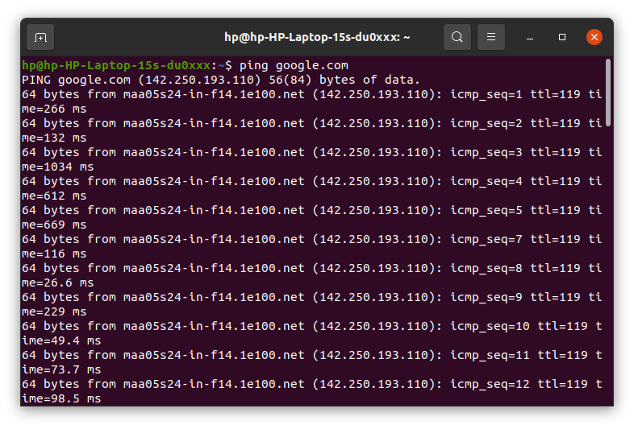

**7.1.2.TRACEROUTE COMMAND**

Traceroute command in Linux prints the route that a packet takes to reach the host. This command is useful when you want to know about the route and about all the hops that a packet takes. Below image depicts how traceroute command is used to reach the Google (172.217.26.206) host from the local machine and it also prints detail about all the hops that it visits in between.

Syntax: traceroute [options] host_Address [pathlength]

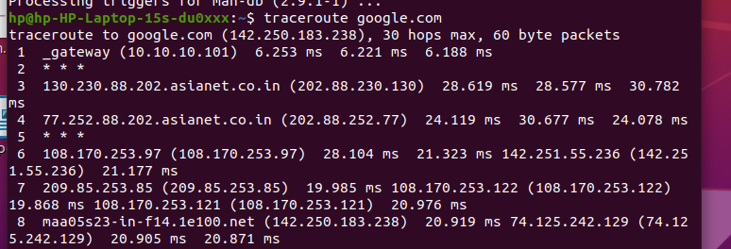

**7.1.3.ROUTE COMMAND**

route command in Linux is used when you want to work with the IP/kernel routing table. It is mainly used to set up static routes to specific hosts or networks via an interface. It is used for showing or update the IP/kernel routing table.

Syntax: route

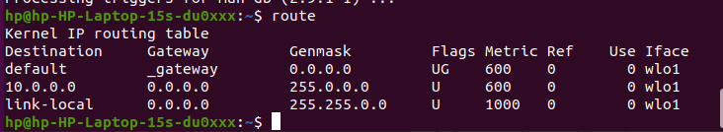

**7.1.4.NSLOOKUP COMMAND**

nslookup (stands for “Name Server Lookup”) is a useful command for getting information from DNS server. It is a network administration tool for querying the Domain Name System (DNS) to obtain domain name or IP address mapping or any other specific DNS record. It is also used to troubleshoot DNS related problems.

Syntax: nslookup [option]

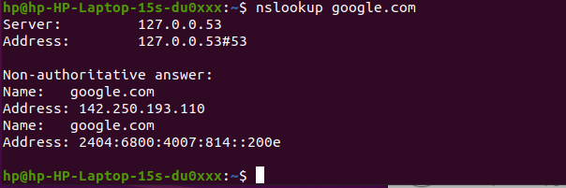

**7.1.5. IFCONFIG COMMAND**

ifconfig(interface configuration) command is used to configure the kernel-resident network interfaces. It is used at the boot time to set up the interfaces as necessary. After that, it is usually used when needed during debugging or when you need system tuning. Also, this command is used to assign the IP address and netmask to an interface or to enable or disable a given interface.

Syntax: ifconfig [...OPTIONS] [INTERFACE]

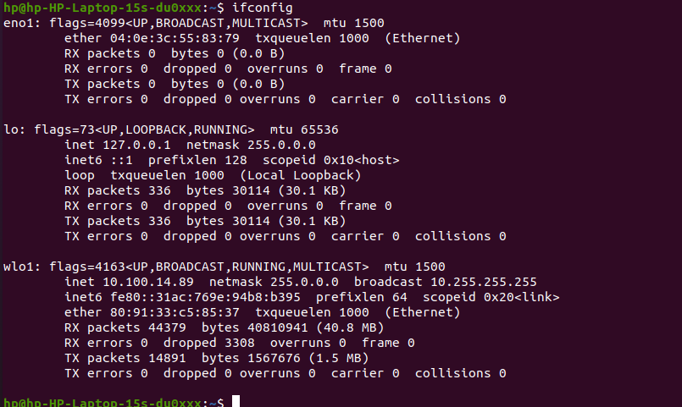

**EXPERIMENT-08**

**8.1 WIRESHARK installation**

Wireshark is a free and open source packet analyser used for network troubleshooting and analysis.

* + 1. Downloading steps

1. Open a web browser.

2. Navigate to http://www.wireshark.org.

3. Select Download Wireshark.

4. Select the Wireshark Windows Installer matching your system type. Save the program in the Downloads folder.

5. Close the web browser.

**8.1.3.** Installation process

1.  Double-click on the file to open it.

2. If you see a User Account Control dialog box, select Yes to allow the program to make changes to this computer.

3. Select Next &gt; to start the Setup Wizard.

4. Review the license agreement. If you agree, select I Agree to continue.

5. Select Next &gt; to accept the default components.

6. Select the shortcuts you would like to have created. Leave the file extensions

selected. Select Next &gt; to continue.

7. Select Next &gt; to accept the default install location.

8. Select Install to begin installation.

9. Select Next &gt; to install WinPcap.

10. Select Next &gt; to start the Setup Wizard.

11. Review the license agreement. If you agree, select I Agree to continue.

12. Select Install to begin installation.

13. Select Finish to complete the installation of WinPcap.

14. Select Next &gt; to continue with the installation of Wireshark.

15. Select Finish to complete the installation of Wireshark.

1.8.4. Demonstrate the process to filtering SMTP packets.

1)) Capturing SMTP packets

1. Start a Wireshark capture.

2. Open a command prompt.

3. Type telnet gmail-smtp-in.l.google.com 25 and press Enter. If this does not

work, your ISP may be blocking outbound traffic on port 25. You can try telnet

smtp.gmail.com 587 instead to generate SMTP traffic and then filter on port 587 in the next activity.

4. Observe the server response.

5. Type helo and press Enter.

6. Observe the server response. Note that at this point you could enter mail, rcpt and data to send an SMTP message, but this only works on servers configured.

to allow clear text relay without authentication.

7. Type quit and press Enter to close the connection.

8. Observe the server response.

9. Close the command prompt.

10. Stop the Wireshark capture.

1. 2))Select destination Traffic

1. Observe the traffic captured in the top Wireshark packet list pane. To view only SMTP traffic, type smtp (lower case) in the Filter box and press Enter.

2. Select the first SMTP packet labelled 220 ....

3. Observe the destination IP address.

4. To view all related traffic for this connection, change the filter to ip.addr

== &lt;destination&gt;, where &lt;destination&gt; is the destination address of the SMTP

packet.

1. 3))Analysing TCP connection traffic

1. Observe the traffic captured in the top Wireshark packet list pane. The first

three packets (TCP SYN, TCP SYN/ACK, TCP ACK) are the TCP three way

handshake. Select the first packet.

2. Observe the packet details in the middle Wireshark packet details pane. Notice that it is an Ethernet II / Internet Protocol Version 4 / Transmission Control Protocol frame.

3. Expand Ethernet II to view Ethernet details.

4. Observe the Destination and Source fields. The destination should be your

default gateway&#39;s MAC address and the source should be your MAC address.You can use ipconfig /all and arp -a to confirm.

5. Expand Internet Protocol Version 4 to view IP details.

6. Observe the Source address. Notice that the source address is your IP address.

7. Observe the Destination address. Notice that the destination address is the IP address of the SMTP server.

8. Expand Transmission Control Protocol to view TCP details.

9. Observe the Source port. Notice that it is a dynamic port selected for this HTTP connection.

10. Observe the Destination port. Notice that it is smtp (25). Note that all of the packets for this connection will have matching MAC addresses, IP addresses,and port numbers.

1. ))Analyse SMTP Service Ready Traffic

1. Observe the traffic captured in the top Wireshark packet list pane.

2. Select the fourth packet, which is the first SMTP packet and labeled 220 ....

3. Observe the packet details in the middle Wireshark packet details pane. Notice that it is an Ethernet II / Internet Protocol Version 4 / Transmission Control Protocol / Hypertext Transfer Protocol frame. Also notice that the Ethernet II, Internet Protocol Version 4, and Transmission Control Protocol values are consistent with the TCP connection analysed in Activity 3.

4. Expand Simple Mail Transfer Protocol and Response to view SMTP details.

5. Observe the Response code and Response parameter.

6. Observe the traffic captured in the top Wireshark packet list pane.

7. Select the fifth packet, labelled TCP ACK. This is the client TCP

acknowledgement of receiving the Service Ready message.

1. 5))Analyse SMTP HELO Traffic

1. Observe the traffic captured in the top Wireshark packet list pane.

2. Select the following TCP segments and acknowledgements. If you observe the packet details in the bottom Wireshark packet bytes pane carefully, you will see that the segments spell out the helo message. The sequence ends with a Wireshark-combined SMTP client helo message, followed by a server TCP

acknowledgement.

1. 6)) Analyse SMTP Completed Traffic

1. Observe the traffic captured in the top Wireshark packet list pane.

2. Select the following SMTP packet, labeled 250 ...

3. Observe the packet details in the middle Wireshark packet details pane.

4. Expand Simple Mail Transfer Protocol and Response to view SMTP details.

5. Observe the Response code and Response parameter.

1. 7))Analyse SMTP QUIT Traffic

1. Observe the traffic captured in the top Wireshark packet list pane.

2. Select the following TCP segments and acknowledgements. If you observe the packet details in the bottom Wireshark packet bytes pane carefully, you will see that the segments spell out the quit message. The sequence ends with a Wireshark-combined SMTP client quit message, followed by a server TCP acknowledgement.

1. 8 ))Analyse SMTP Closing Traffic

1. Observe the traffic captured in the top Wireshark packet list pane.

2. Select the following SMTP packet, labelled 221 ...

3. Observe the packet details in the middle Wireshark packet details pane.

4. Expand Simple Mail Transfer Protocol and Response to view SMTP details.

5. Observe the Response code and Response parameter.

6. Close Wireshark to complete this activity. Quit without Saving to discard the

captured traffic.

**8.1.5. SMTP Process**

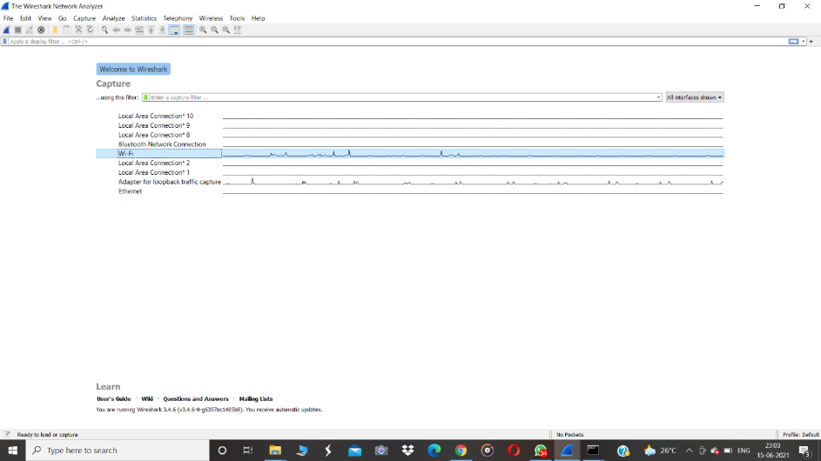

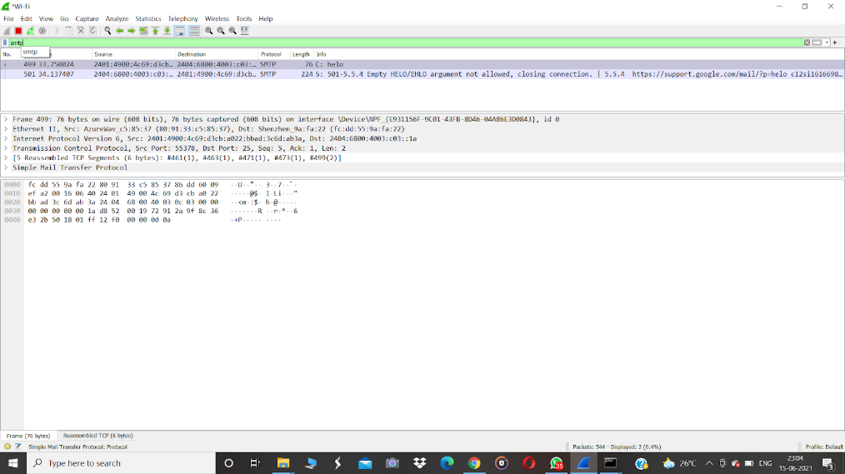

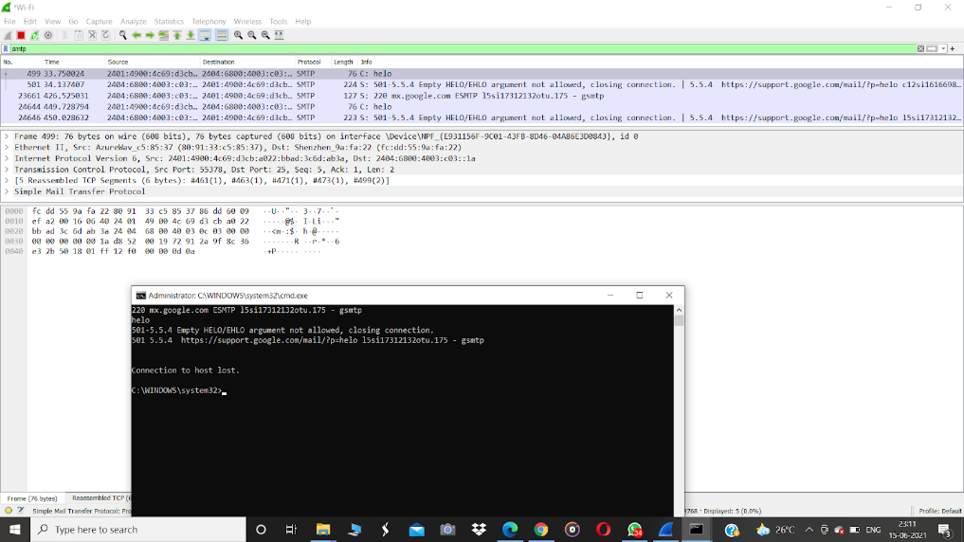

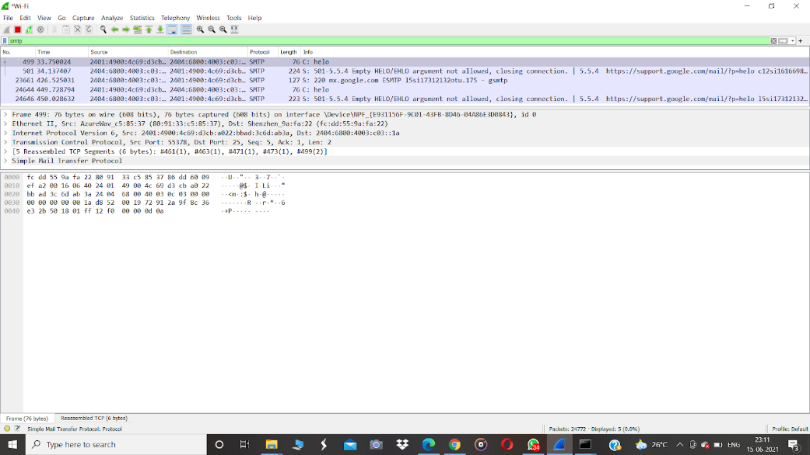

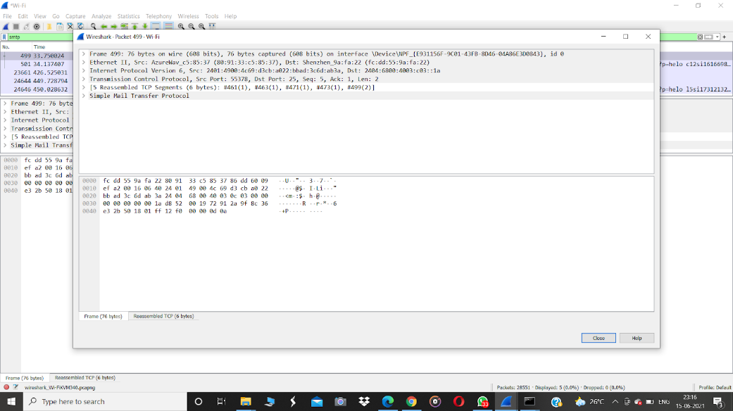

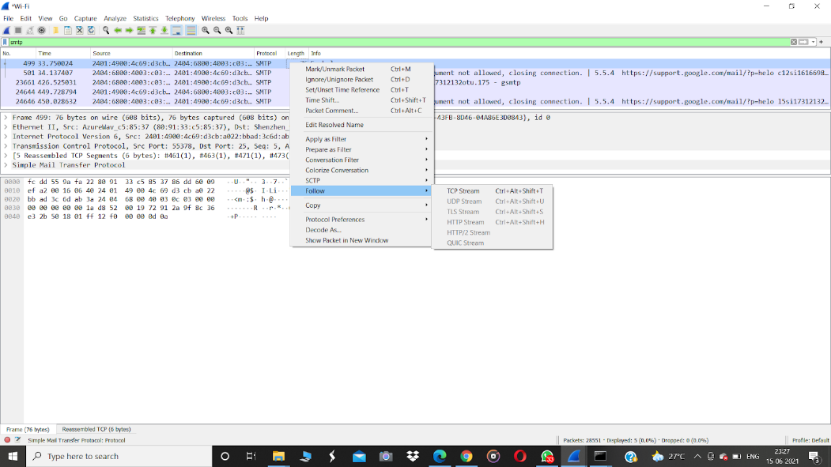

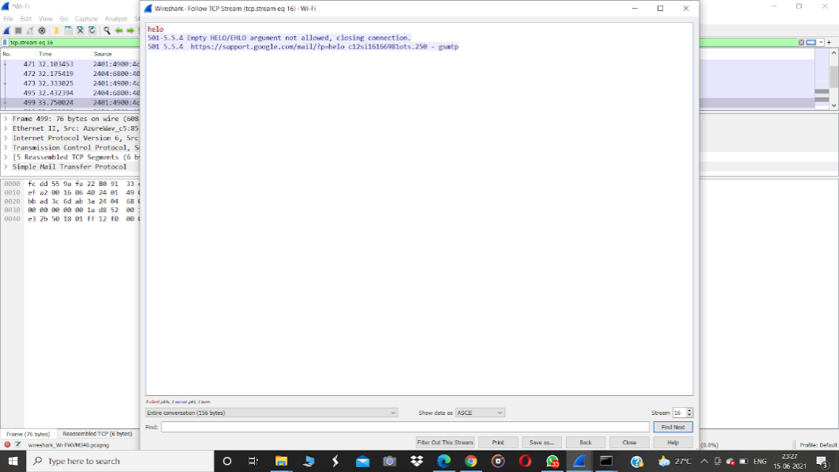

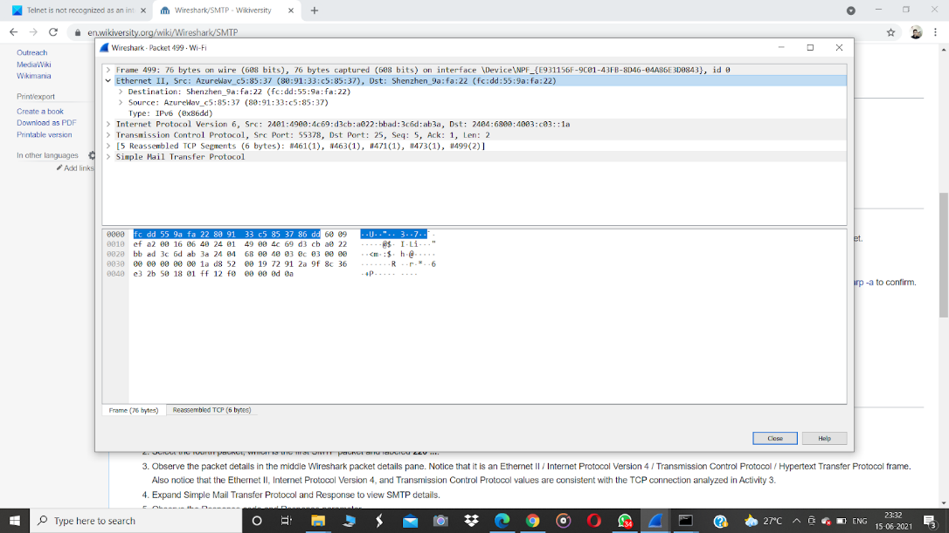

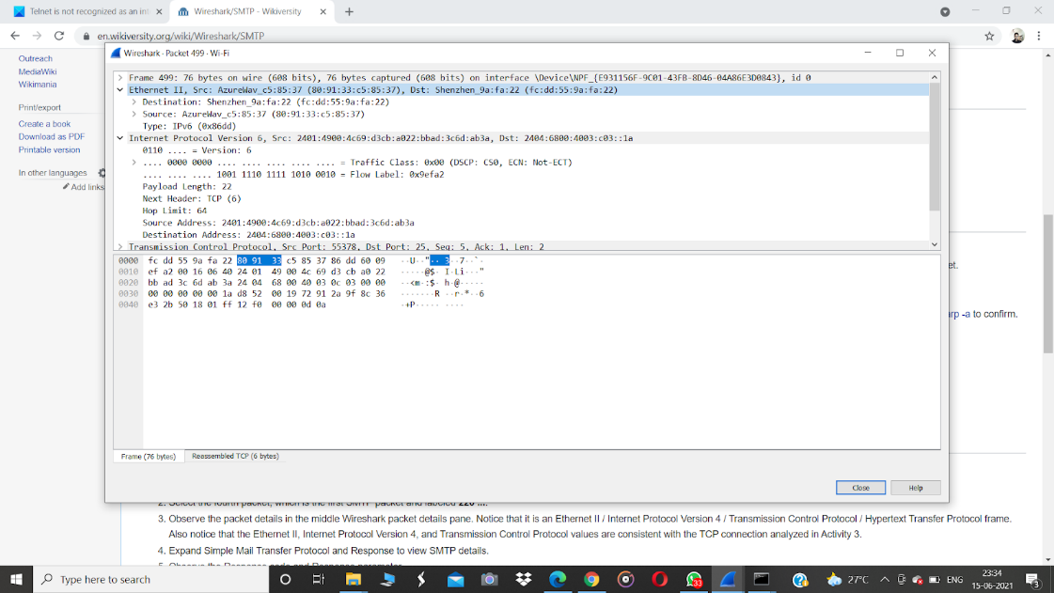

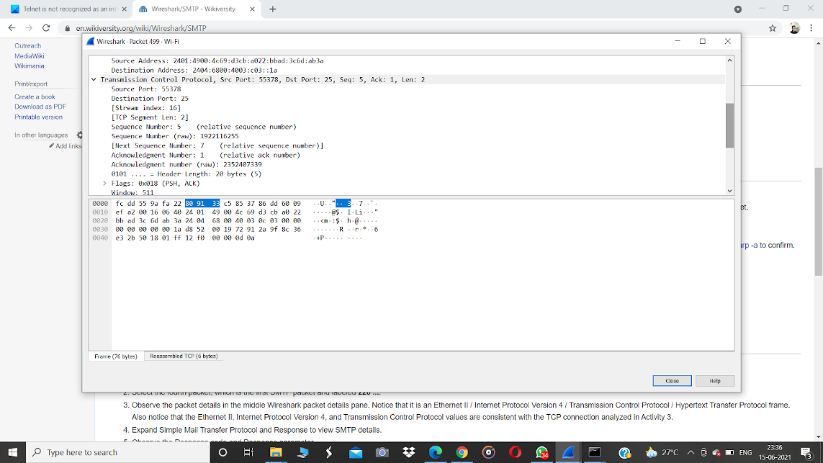

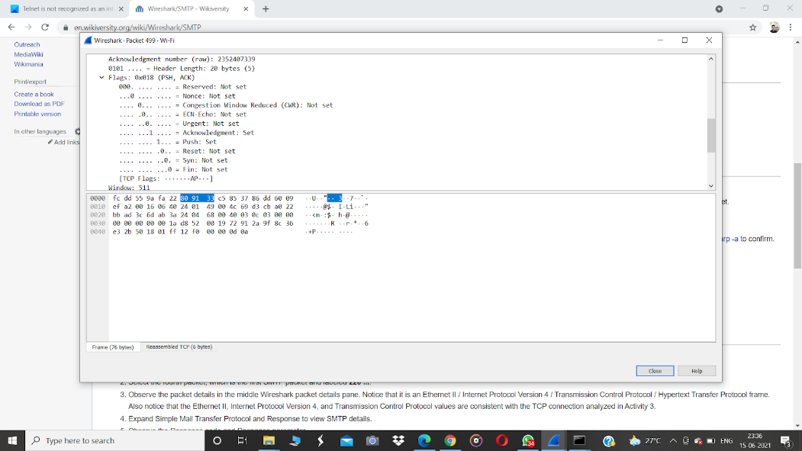

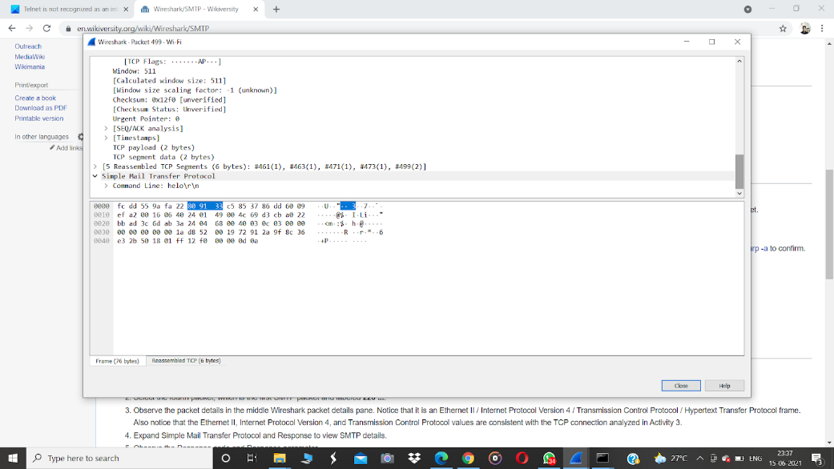

**EXPERIMENT-09**

**9.1. Introduction to Virtual Machine and installation**

***9.1.2. Creating a Virtual Machine***

**9.1.2.1** [**Install VirtualBox**](https://www.wikihow.com/Install-VirtualBox)**.**

If you don't already have VirtualBox installed on your Windows or Mac computer, you'll need to install it before proceeding.

 Following are the steps required to install VirtualBox(Oracle VM VirtualBox):

You can download the latest version of VirtualBox from the Virtual Box website: [**https://www.virtualbox.org/wiki/Downloads**](https://www.virtualbox.org/wiki/Downloads)according to the version of your operating system Windows, Mac or Linux.

* Click Next

[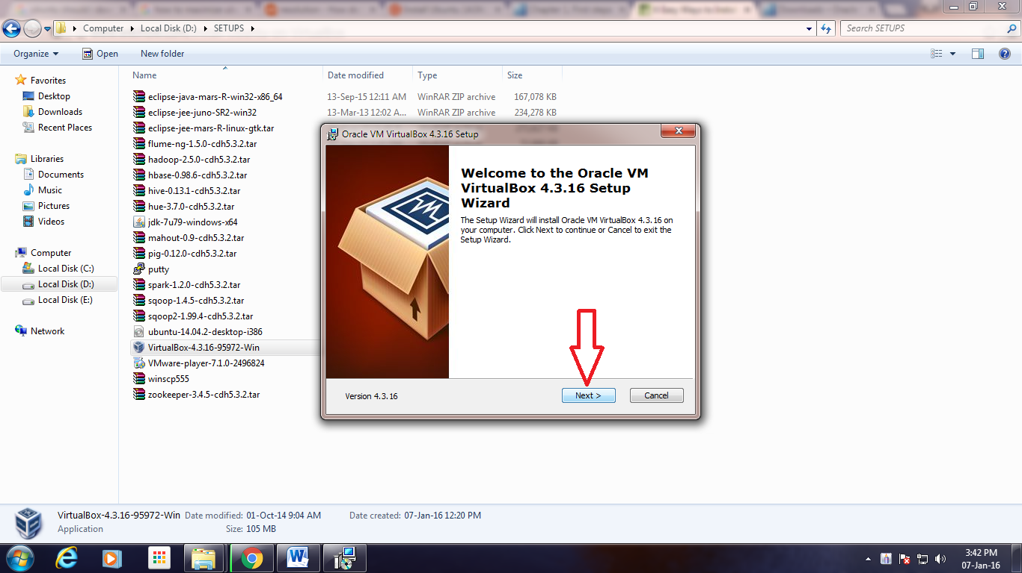](https://data-flair.training/blogs/wp-content/uploads/sites/2/2016/06/Setup-Wizard.png)

To Install VirtualBox – Setup Wizard

* Click Next

[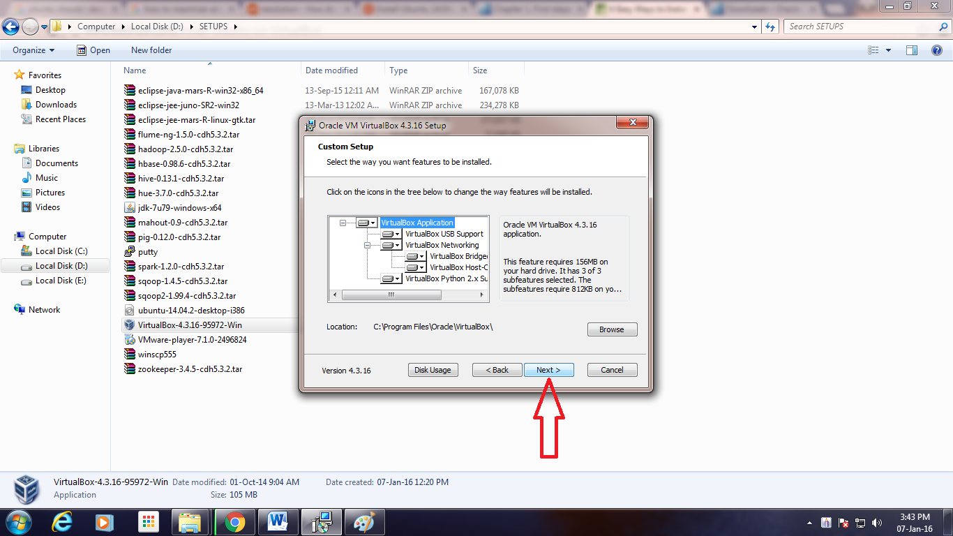](https://data-flair.training/blogs/wp-content/uploads/sites/2/2016/06/Custom-Setup.png)

To Install VirtualBox – Custom Setup

* Uncheck “Create a shortcut in the Quick Launch Bar” and click “Next”

[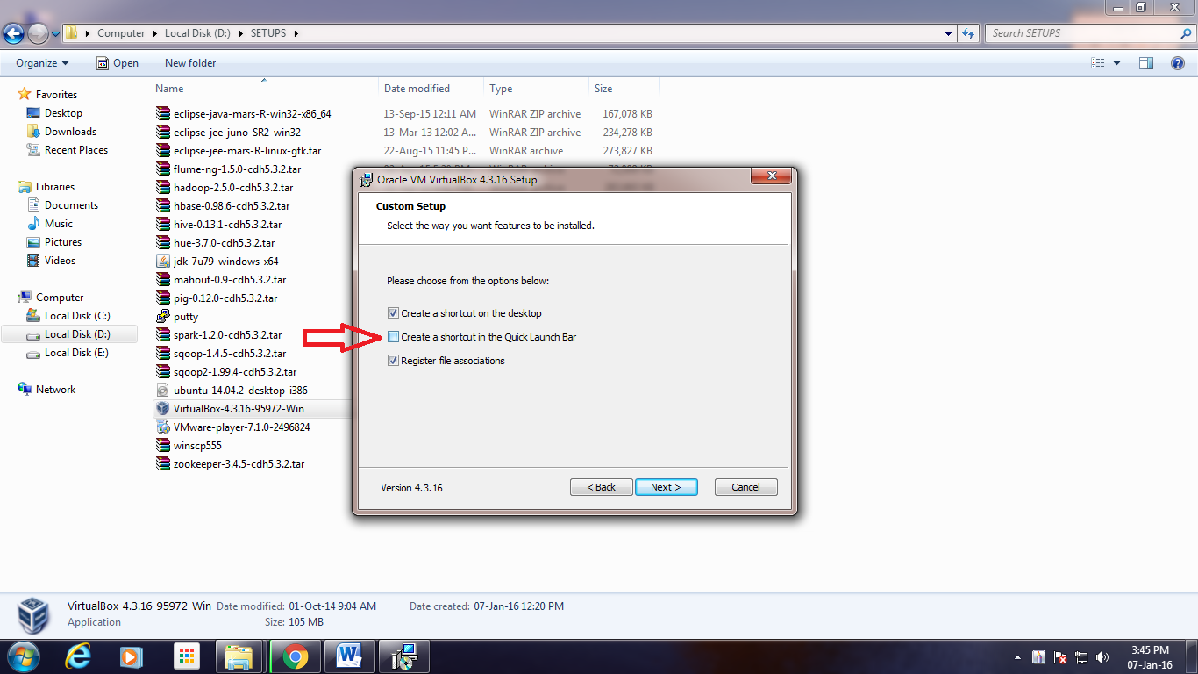](https://data-flair.training/blogs/wp-content/uploads/sites/2/2016/06/Features-Selection.png)

To Install VirtualBox – Features Selection

* Click “Yes”

[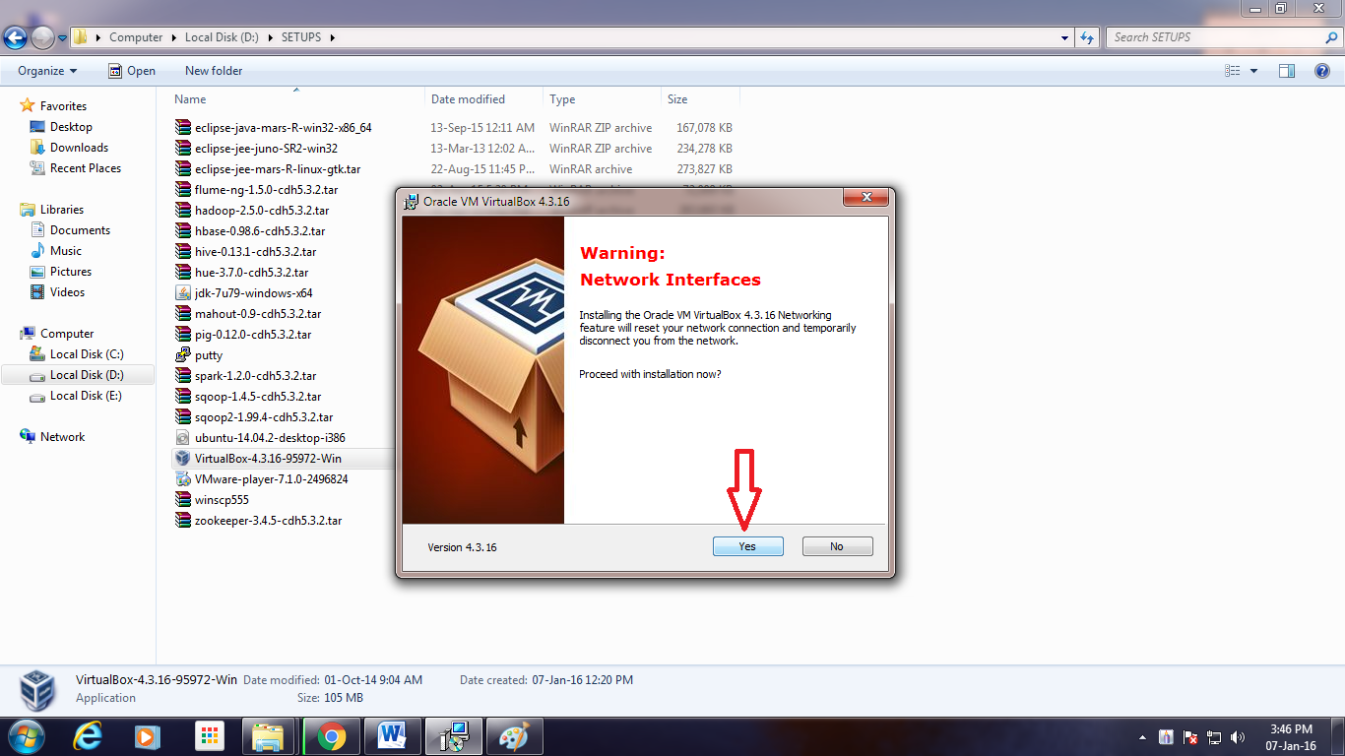](https://data-flair.training/blogs/wp-content/uploads/sites/2/2016/06/Network-Interfaces-Warning.png)

To Install VirtualBox – Network Interfaces Warning

* Click “Install”

[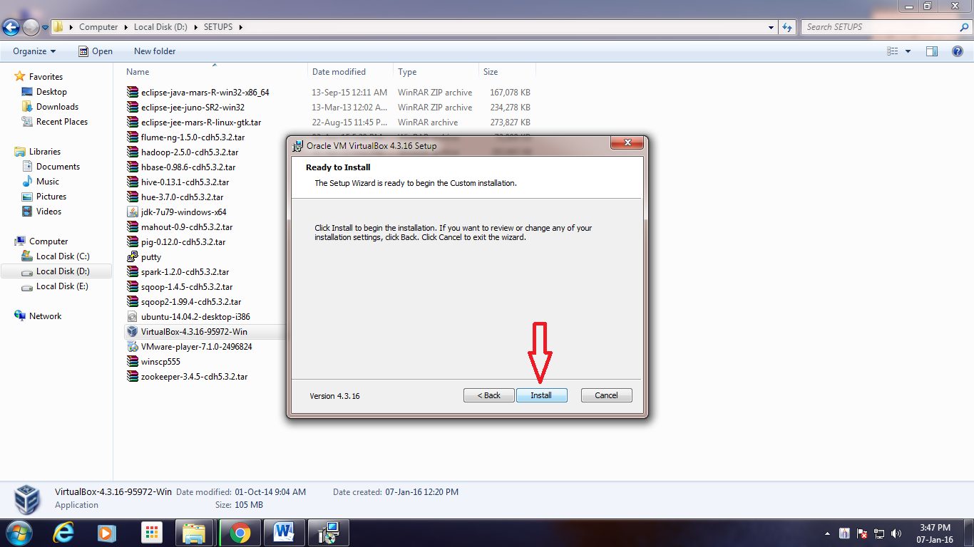](https://data-flair.training/blogs/wp-content/uploads/sites/2/2016/06/Ready-to-Install.png)

Installation of Oracle VM VirtualBox – Ready to Install

* Click “Install”

[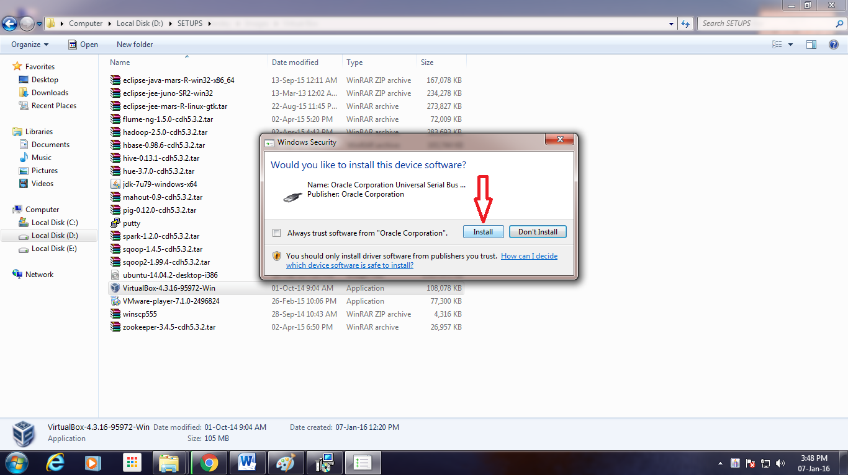](https://data-flair.training/blogs/wp-content/uploads/sites/2/2016/06/Serial-Bus-Software-Installation.png)

Installation of Oracle VM VirtualBox- Serial Bus Software Installation

* . Click “Install”

[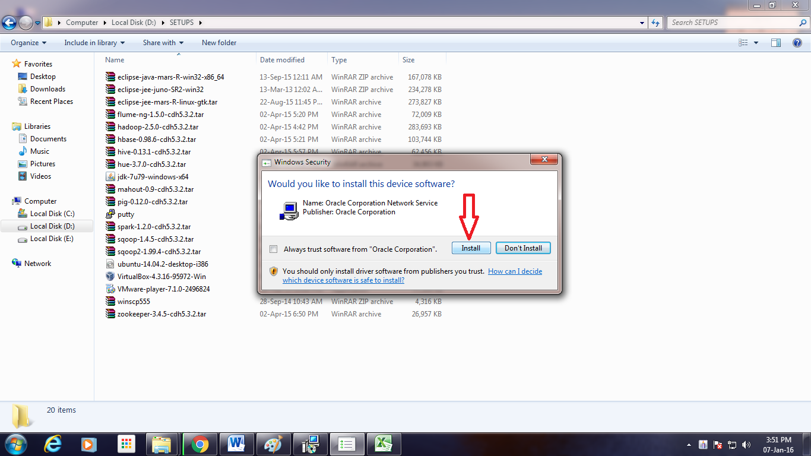](https://data-flair.training/blogs/wp-content/uploads/sites/2/2016/06/Network-Service-Installation.png)

Installation of Oracle VM VirtualBox – Network Service Installation

* Click “Install”

[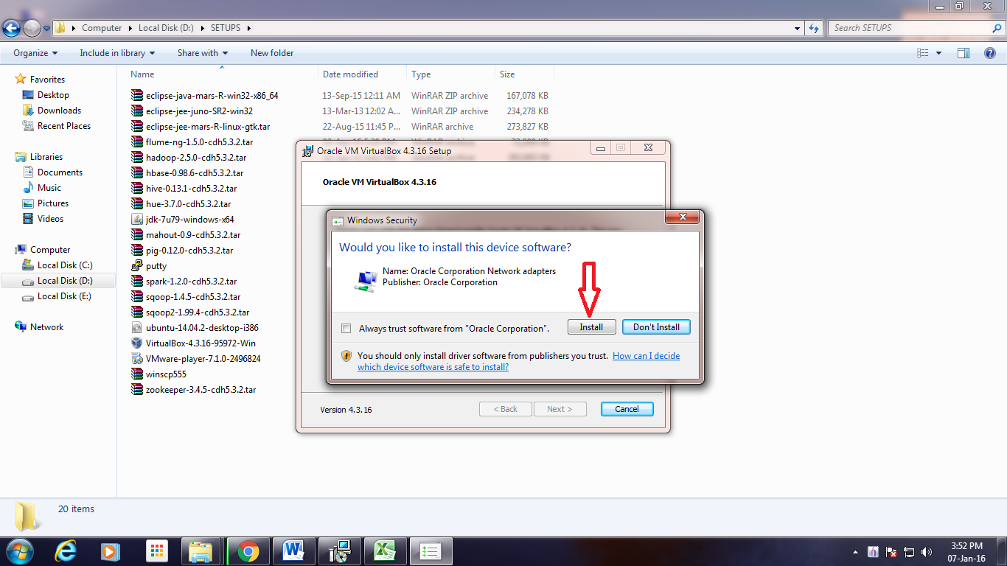](https://data-flair.training/blogs/wp-content/uploads/sites/2/2016/06/Network-Adapters-Installation.png)

Installation of Oracle VM VirtualBox – Network Adapters Installation

* Click “Finish”

[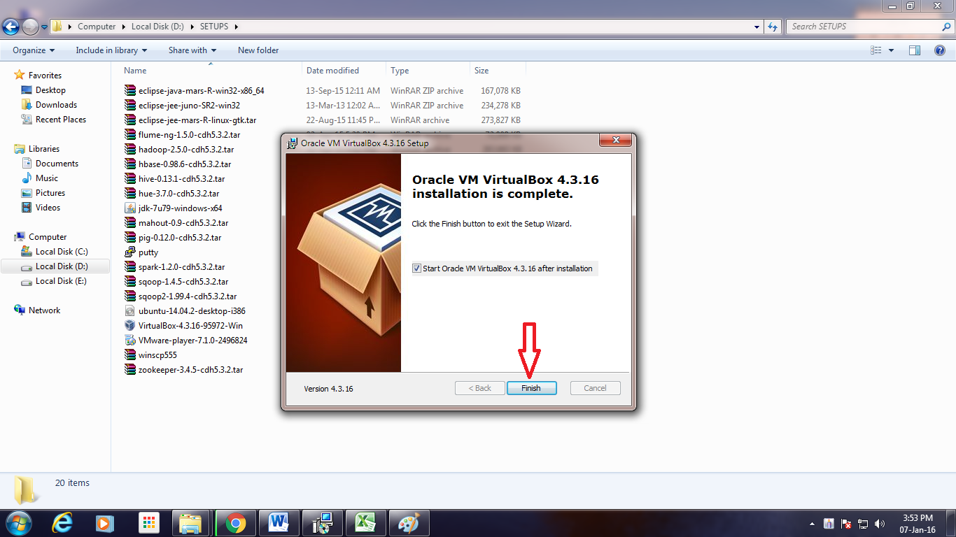](https://data-flair.training/blogs/wp-content/uploads/sites/2/2016/06/Exit-Setup-Wizard.png)

***9.1.2.*2. Open VirtualBox.** Double-click (or click once on a Mac) the VirtualBox app icon.

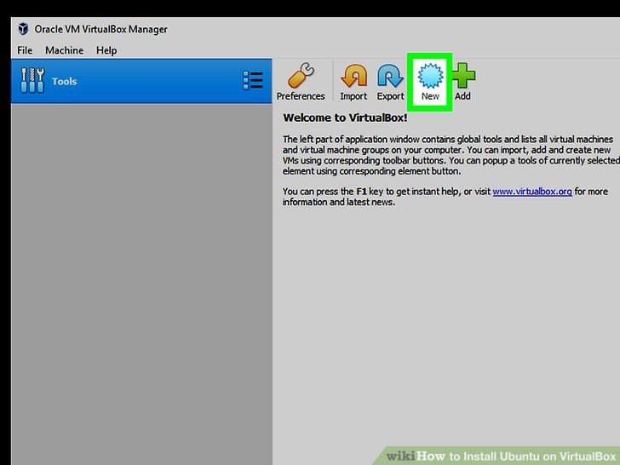

**Click New.** It's a blue badge in the upper-left corner of the VirtualBox window. Doing so opens a pop-up menu.

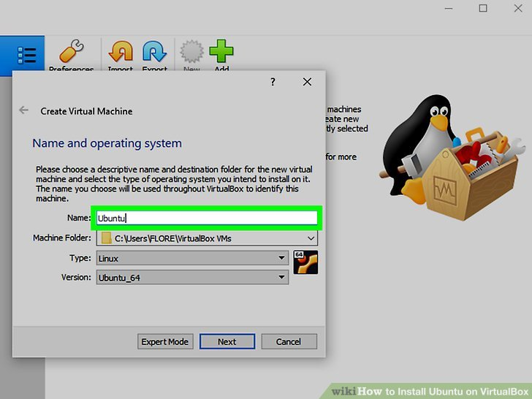

**Enter a name for your virtual machine.** Type whatever you want to name your virtual machine (e.g., Ubuntu) into the "Name" text field that's near the top of the pop-up menu.

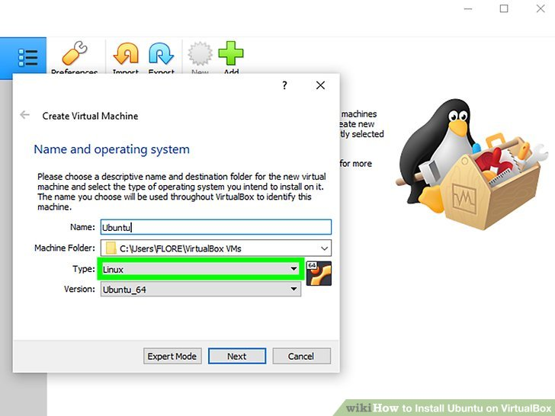

For **Operating System Type**, select the OS that you want to install.

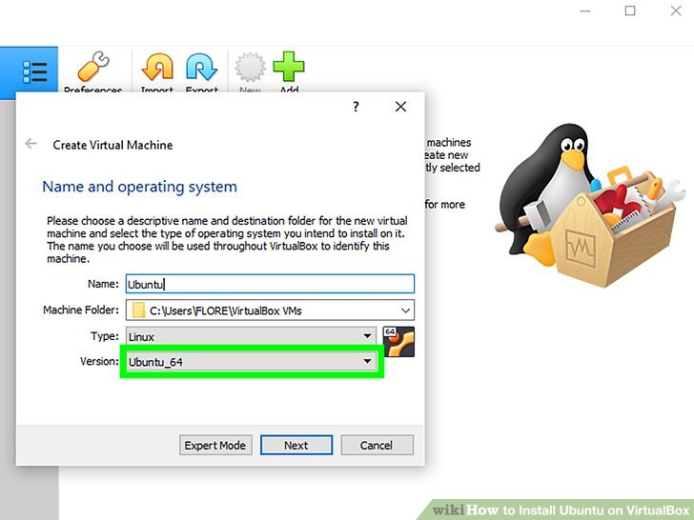

Select the **version** of the operating system.

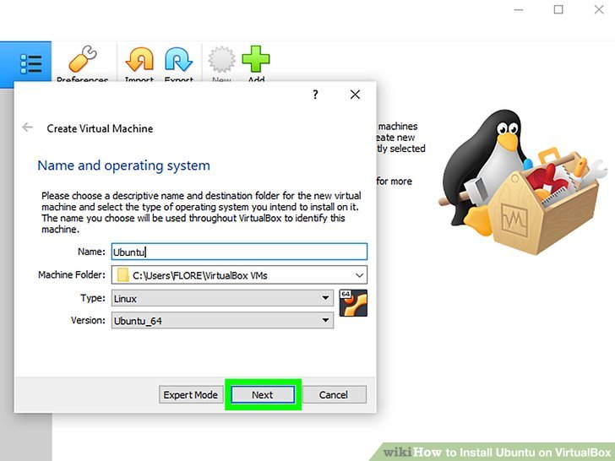

**Click Next.** It's at the bottom of the menu.

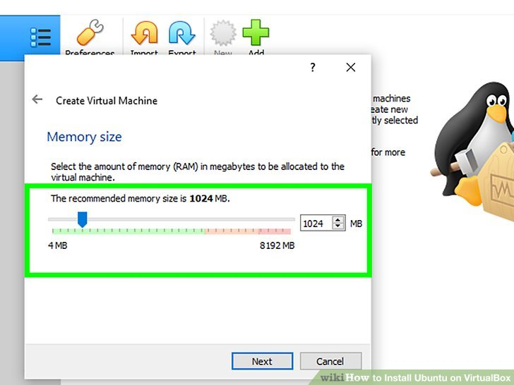

**Select an amount of RAM to use.** Click and drag the slider left or right to decrease or increase the amount of RAM that VirtualBox will have available for your virtual machine.

The ideal amount of RAM will automatically be selected when you get to this page.

Make sure not to increase the RAM into the red section of the slider; try to keep the slider in the green.

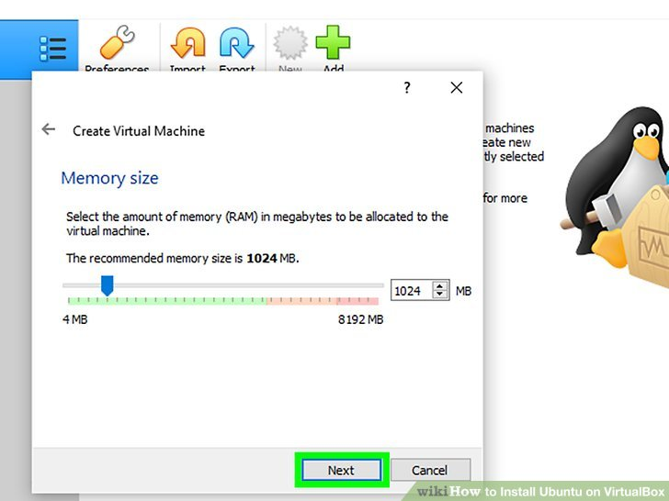

**Click Next.** It's at the bottom of the menu.

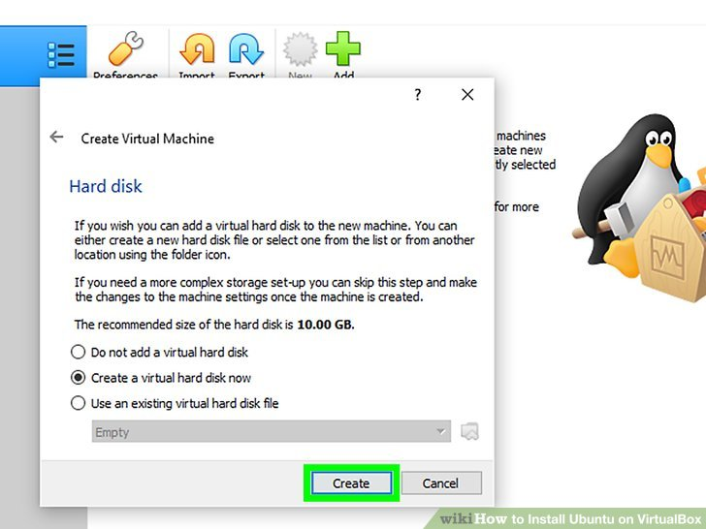

**Create your virtual machine's virtual hard drive.** The virtual hard drive is a section of your computer's hard drive space which will be used to store your virtual machine's files and programs:

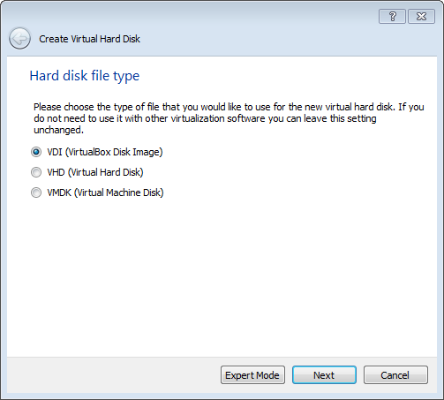

Use “VDI” to create a virtual hard disk

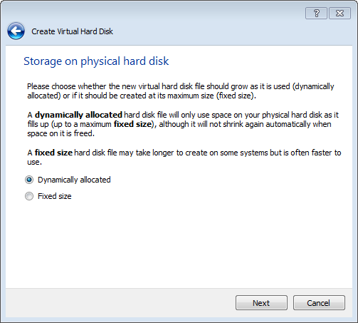

Choose “Dynamically allocated”

Allocate at Minimum 8 GB (recommended 10 or more).

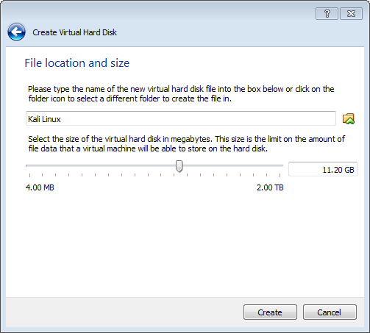

Click **Create**, to create your new virtual machine. The virtual machine is displayed in the list on the left side of the VirtualBox Manager window, with the name that you entered initially.

VMs can run multiple operating system environments on a single physical computer, saving physical space, time and management costs.